

Cuan na Gaillimhe CNS-A Steiner Education
Bí Cineálta Policy to Prevent and Address Bullying Behaviour

The Board of Management of Cuan na Gaillimhe CNS-A Steiner Education has adopted the following policy to prevent and address bullying behaviour. This policy fully complies with the requirements of Bí Cineálta: Procedures to Prevent and Address Bullying Behaviour for Primary and Post-Primary Schools 2024.
The board of management acknowledges that bullying behaviour interferes with the rights of the child as set out in the United Nations Convention on the Rights of the Child. We all, as a school community, have a responsibility to work together to prevent and address bullying behaviour and to deal with the negative impact of bullying behaviour.

We are committed to ensuring that all students who attend our school are kept safe from harm and that the wellbeing of our students is at the forefront of everything that we do. We recognise the negative impact that bullying behaviour can have on the lives of our students, and we are fully committed to preventing and addressing bullying behaviour.
We confirm that we will, in accordance with our obligations under equality legislation, take all such steps that are reasonably practicable to prevent the harassment of students or staff on any of the nine grounds specified: gender, civil status, family status, sexual orientation, religion, age, disability, race and membership of the Traveller community.

Definition of Bullying
  - Bullying is targeted behaviour, online or offline, that causes harm.
  - The harm caused can be physical, social and/or emotional in nature and can have lasting effects on the child experiencing the behaviour.
  - Bullying is repeated over time and involves an imbalance of power in relationships between two people or groups of people in society.
  - It is behaviour which is deliberate in nature and is unwanted. It is not accidental or reckless behaviour.

Behaviour that is not bullying behaviour:

- If repeated harm is real for the student experiencing the behaviour, but unintended by the other student, this is not bullying, and this must be addressed under the school code of behaviour.
- Some students with special educational needs, may have social communication difficulties which may make them communicate their needs through behaviours that can hurt themselves or others. It is important to note that these behaviours are not deliberate or planned, but in certain situations, they are an automatic response which they cannot control.
- Disagreement between students is not considered bullying unless it involves deliberate and repeated attempts to cause distress, exclude or create dislike by others.

Types of Bullying:
There are many different types of bullying behaviour. These can include directing bullying at someone focused on the following: disability, exceptional ability, gender identity, LGBTQ+, physical appearance, racism, poverty status, religious identity, sexism and sexual harassment. This is not an exhaustive list.
Bullying can be:
Direct:
  - Physical: pushing, shoving, punching, kicking, poking and tripping students. Physical assault. Destruction of personal property.
  - Verbal: continual name calling which insults, humiliates the student – this may refer to physical appearance, size, clothes, gender, accent, academic ability, race or ethnic origin.
- Written: Writing insulting remarks in public places, passing notes or drawings about the student.
  - Extortion: where something is obtained through force or threats

Bullying can be:

Indirect:
  - Exclusion: where a student is deliberately and repeatedly isolated, excluded or ignored by a student or group of students.

  - Relational: Where a student’s attempts to form friendships with peers are repeatedly rejected or undermined, threats, non-verbal gesturing, malicious gossip, spreading rumours, silent treatment and manipulation of friend groups etc. can all form relational bullying for a student.

Online bullying behaviour:
Cyber bullying is carried out via text, direct messaging/instant messaging, social media platforms, e- mail, apps, digital gaming sites, gaming consoles, chatrooms and other online technologies.

This can include:
  - Sending or sharing of insulting and offensive or intimidating messages or images via online means as mentioned above.
  - Posting information, which is personal, private or sensitive without consent.
  - Making and/or participating in fake profiles on a social network to impersonate and/or humiliate other students.
  - Exclude/disrupt access to a student on purpose on online chat groups/access to accounts/from an online game.

Restorative Practice

During school year 2023-2024 the staff of Cuan na Gaillimhe CNS-A Steiner Education received training in Restorative Practice by the Professional Development Service for Teachers (PDST).

Restorative Practice (RP) is based primarily on a set of core values and the explicit promotion and enhancement of skills such as the ability to empathise and to find solutions to specific problems. This practice allows for building trust between and with people. It provides a structured approach in the form of a scaffold, which helps build and sustain relationships, and provides a focus which allows for the potential growth of positive relationships to become established between people. It also provides a platform for dealing with conflict in a healthy manner when conflict occurs. As defined by PDST Professional Development Service for Teachers

During School year 2024-2025 we began the roll out of this RP approach, this includes:
Regular circle time to build relationships and to deal with issues arising. Using a set of 6 questions to guide RP conversations.

Restorative Conversations
When minor conflict or challenging behaviour occurs, conversations take place with one or more children to examine who has been affected and how to address the harm that has been caused.

This RP approach ties in well with our schools’ position on bullying and supports investigations. RP conversations can sometimes help to prevent issues that arise from developing into a bullying situation. They can also help with establishing if bullying is occurring; and with resolving issues. The same basic procedures apply; the language and approach are different.

Section A

Development/ review of our Bí Cineálta policy to prevent and address bullying behaviour

All members of our school community were provided with the opportunity to input into the development/review of this policy.

 | Date consulted | Method of consultation
School Staff | October 2024  November 2024  May 2025  June 2025 | - Document shared with all  - Training day for 2 staff members  - Staff Questionnaire  - Meeting & discussion groups  - Half day training for all staff
Students | May 2025  June 2025 | - Student Anti-Bullying Questionnaire  - Student Council meeting  - Developed Student-friendly policy  - Communicated new policy to students in June.
Parents | November 2024  May 2025 | - Monthly Newsletter Info  - School Email  - Parent Questionnaire  - PTA Focus group meetings
Board of Management | November 2024  March 2024  May 2025  June 2025 | - Document shared with all  - Updates at BOM meetings  - Policy ratified
Wider school | June 2025 | - Afterschool  - Bus drivers  - Music Generation  - Club Gaeilge
community as
appropriate, for
example, bus driver, after school, Music Generation
Section B

Preventing Bullying Behaviour
This section sets out the prevention strategies that will be used by the school. These include strategies specifically aimed at preventing online bullying behaviour, homophobic and transphobic bullying behaviour, racist bullying behaviour, sexist bullying behaviour and sexual harassment as appropriate (see Chapter 5 of the Bí Cineálta procedures):

Culture and Environment
A positive and inclusive school culture and environment is essential to prevent and address bullying behaviour. We endeavour to create a values-centred space where students and school staff experience a sense of belonging and feel safe, connected and supported. Relationships between all members of the school community are based on respect, care, integrity and trust.

Open communication between the patron, boards of management, school staff, students and their parents help to foster a collaborative approach and share responsibilities in relation to preventing and addressing bullying behaviour.

The school leadership team influences the school culture and set the standards and expectations for the school community when preventing and addressing bullying behaviour.

Each member of school staff contributes to developing and maintaining a school culture where bullying behaviour is unacceptable and takes a consistent approach to addressing bullying behaviour.

Students help shape the school culture by promoting kindness and inclusion within their peer group and maintain a positive and supportive school environment for all.

Parents, as active partners in their child’s education, help foster an environment where bullying behaviour is not tolerated through promoting empathy and respect.

The culture of the school is that it is a Telling School. The students are frequently encouraged to be a brave upstander; to stand up to bullying behaviours; and not a bystander (part of the problem). Students are frequently reminded to tell staff members when they witness misbehaviours and are made aware of the importance of telling. They are assured that this is not telling tales. They are reassured that this telling will help the target and the perpetrator. On becoming aware of any bullying situation, in or outside the school, involving members of the school community students are asked to notify a trusted, responsible adult. Bullying behaviour is too serious not to report.

A t rusted adult may be helpful in encouraging students to report. Where needed, we ensure that a student is aware of who their trusted adult/s might be.

We create a safe physical space
By ensuring the visibility of school staff, including teachers, SNA’s, interns, and management who supervise students during outside play or any other time.

All students are expected to contribute to the creation and maintenance of a safe environment in the school.

The availability of spaces within our school inside & out for collaborative learning/play fosters a sense of belonging, and students are given ownership of their own space through play opportunities, gardening, art and creativity. This helps students to feel a sense of responsibility for their school environment. The school grounds are well maintained to promote a sense of ownership and respect in the school community.

Supervision
Appropriate supervision by all staff, is an important measure to help prevent and address bullying behaviour. We take all reasonable measures to ensure the safety of all students and to supervise carefully when attending school or attending school activities. Certain children are identified as needing more support outside and so a staff member may be focused on supervising that child.

Curriculum Teaching and learning that is collaborative and respectful is promoted. Students have regular opportunities to work in small groups with their peers, which helps build a sense of connection, belonging and empathy among students. The curricular subjects offered to students provide opportunities to foster inclusion and respect for diversity. We provide opportunities for students to develop a sense of self-worth through both curricular and extracurricular programmes.

The Social Personal and Health Education (SPHE) and Relationships and Sexuality Education (RSE) curricula at primary level aim to foster students’ wellbeing, self-confidence and sense of belonging and to develop students’ sense of personal responsibility for their own behaviour and actions. Students’ social and emotional learning (SEL) skills can be improved through the SPHE curriculum.

The education and prevention strategies used by the school are as follows:
The anti-bullying module of the SPHE programme applies during each school year.

At least five awareness-raising exercises per school year for each class group, proactively explaining the nature and variety, causes, consequences and unacceptability of bullying, for one week every second month (e.g. Oct, Dec, Feb, April, June).

Students can also consider diversity, and inclusion can be experienced via Community National School Goodness Me Goodness You programme (GMGY), which aims to encourage respect and understanding of different beliefs, perspectives and ways of living.

Policy and Planning
We are working towards the wellbeing of the school community, being at the heart of school policies and plans. The student-friendly Bí Cineálta policy to prevent and address bullying behaviour has been developed by our students. There are a range of other policies such as the school’s acceptable use policy, supervision policy, special education teaching policy and Code of Behaviour that support implementation of a school’s Bí Cineálta policy.

Supporting the participation of students in the development and implementation of school policies and plans helps increase awareness and ensure effective implementation. Engaging in appropriate teacher professional learning courses supports school staff to prevent and address bullying behaviour.

School staff share their experiences and examples of best practice. A range of training is available for school staff e.g. Restorative Practice Training 2023/2024 and RELATE CPD training 2025/2026

Relationships and Partnerships
Strong interpersonal connections are a vital part of effectively preventing and addressing bullying behaviour. These interpersonal connections are supported through a range of formal and informal structures such as student councils, school clubs, and PTA following, which is not an exhaustive list, strengthen relationships and partnerships between members of the school community:
- supporting the active participation of students in school life
- supporting the active participation of parents in school life
- conducting workshops and seminars for students, school staff and parents to raise awareness of the impact of bullying
- supporting activities that build empathy, respect and resilience
- encouraging peer support such as peer mentoring
- promoting acts of kindness
- teaching problem solving
- Restorative Practice and wellbeing work: Circle time; RP questions.
- Goodness Me Goodness You programme

Cineáltas: Action Plan on Bullying recognises the importance of positive relationships across the whole education community to promote empathy, understanding and respect. The meaningful involvement of the board of management, staff, students and their parents in the development, implementation and review of their school’s Bí Cineálta policy and student friendly version is essential to effectively prevent and address bullying behaviour.

When implementing a prevention strategy, we engage with members of the wider school community who are in regular contact with students, such as the following, which is not an exhaustive list: Afterschool, Bus driver, Music Generation, Club Gaeilge, local businesses that are close to the school. These members of the wider school community are encouraged to report any bullying.

Section C

Addressing Bullying Behaviour
The whole school community has a responsibility to prevent and address bullying behaviour. We work in partnership with our patron, board of management, staff, students and their parents in developing and implementing this Bí Cineálta policy.

The steps that will be taken by the school to determine if bullying behaviour has occurred
Identifying if bullying behaviour has occurred (See Appendix 1)

Teaching and non-teaching staff such as secretaries, Special Needs Assistants, caretakers and cleaners must report any incidents of bullying behaviour witnessed by them, or mentioned to them, to the relevant teacher. Any student or parent/guardian or staff member may bring a bullying incident to any teacher in the school. The Principal must always be informed.

All reports, including anonymous reports of bullying will be investigated and dealt with by the relevant teacher (class teacher).

To determine whether the behaviour reported is bullying behaviour the following will be considered (see definition of bullying p.1/2. of this policy).

Is the behaviour targeted at a specific student or group of students?
Is the behaviour intended to cause physical, social or emotional harm?
Is the behaviour repeated?
If the answer to each of the questions above is Yes, then the behaviour is bullying behaviour, and the behaviour should be addressed using the Bí Cineálta Procedures.

If the answer to any of these questions is No, then the behaviour is not bullying behaviour.

The class teacher investigates all instances of reported or suspected bullying behaviour, with a view to establishing the facts. Where possible, incidents should be investigated outside of the classroom situation to ensure the privacy of all involved. All conversations should be conducted with sensitivity and with due regard to the rights of all students concerned, including their right to confidentiality, where appropriate. Students who are not directly involved can also provide very useful information in this way.

- The relevant teacher should seek answers to questions of what, where, when, and who; in a calm manner, setting an example in dealing effectively with a conflict in a non-aggressive manner. The child’s age and stage of development will be taken into consideration.
- If a group is involved, engagement will be with each individually at first. Thereafter, all those involved may be met as a group, if agreeable with all.
- At the group meeting, each member should be asked for their account of what happened to ensure that everyone in the group is clear about each other’s views. It also may be helpful to ask those involved to write down their account of the incident(s).
- Otherwise, a consensus will be agreed without bringing all involved together.
- Each student should be supported as appropriate

Incidents can occur where behaviour is unacceptable and hurtful, but the behaviour is not bullying behaviour. Strategies that deal with inappropriate behaviour are provided for within our code of behaviour and RP questions will also guide this process.

If it is unclear if it is Bullying, the situation will be closely monitored for a period of 5 to max 10 days by specific staff members. The principal/Deputy principal will work with the class teacher to support the monitoring process. The class teacher will record any events and follow up.

If the behaviour is not bullying, the suspected bullying is recorded along with any monitoring and outcome as per Appendix 1 of this policy. A paper copy is given to the principal and filed in the principal’s office.

Record and Address ( See Apendix 2)

Note: A school is not expected to deal with bullying behaviour that occurs when students are not under the care or responsibility of the school. However, where this bullying behaviour has an impact in school, schools are required to support the students involved. Where the bullying behaviour continues in school, we will deal with it in accordance with our Bí Cineálta policy.

Where the student displaying the bullying behaviour is not a student in the school, but the student who is experiencing the bullying behaviour is a student in the school, we will support the student who is experiencing the bullying behaviour as appropriate and engage with them and their parents to determine what steps can be taken.

Approach where it is established that bullying behaviour has occurred/is occurring:

It is important for school staff to be fair and consistent in their approach to address bullying behaviour. Both the student who is experiencing bullying behaviour and the student who
is displaying bullying behaviour and need support. It is important that the student who is experiencing bullying behaviour is engaged without delay so that they feel listened to, supported and reassured. School staff will identify the support needed for the student who is displaying bullying behaviour to better manage relational difficulties and endeavour to meet their needs.

A student’s agency or sense of power can be decreased when they experience or witness bullying behaviour. When a student tells an adult that they feel that they are experiencing bullying, they may feel more control over what is happening to them. It is very important that a student agency is not decreased further by adults deciding what will happen next without listening to the student and involving them in deciding on the actions that will be taken.

When bullying behaviour occurs, we aim to stop the bullying behaviour and to restore, as far as practicable, the relationships of the students involved, rather than to apportion blame. we will:

- ensure that the student experiencing bullying behaviour is heard and reassured
seek to ensure the privacy of those involved
- conduct all conversations with sensitivity
- consider the age and ability of those involved
- listen to the views of the student who is experiencing bullying behaviour as to how best to address the situation
- act in a timely manner
- inform parents of those involved

Investigating and dealing with bullying
The primary aim for the relevant teacher in investigating and dealing with bullying is to resolve any issues and to restore, as far as it is practicable, the relationships of the parties involved:

- The class teacher investigates with a view to establishing the facts, seeking answers to questions of what, where, when, who and why.
- The teacher listens to the views of the student who is experiencing bullying behaviour as to how best to address the situation
- If a group is involved, the teacher engages with each member individually at first.
- Students who are not directly involved may also provide useful information
- Staff members may be consulted, where appropriate.
- Thereafter, all those involved may be met as a group, if agreeable with all. At the group meeting, each member should be asked for his/her account of what happened to ensure that everyone in the group is clear about each other’s statements. Otherwise, a consensus will be agreed without bringing all involved together.
- Each member of a group should be supported through the possible pressures that may face them from other members of the group, after the conversation with the teacher. It also may be appropriate or helpful to ask those involved to write down their account of the incident(s).
- The parents/guardians of the parties involved will be contacted at an early stage to inform them of the matter and explain the actions being taken and to consult with them on the actions to be taken to address the behaviour. Parents/guardians may be given an opportunity of discussing ways in which they can reinforce or support the actions being taken by the school.
- While all bullying is completely unacceptable, the seriousness of the bullying behaviours and the individual child’s role within it will be considered; and follow up actions will be in line with this.
- The class teacher will record the following, as per Appendix 2
- Engagement with all involved
- Form and type of bullying, if known
- Where and when took place
- Date of initial engagement with students and parents
- Agreed actions to be taken and the views of the students and parents regarding the actions to be taken

Review
Follow up where bullying behaviour has occurred (See Appendix 2)

The teacher will engage with the students involved and their parents again no more than 20 school days after the initial engagement to review progress.
Important factors to consider as part of this engagement are the nature of bullying behaviour, the effectiveness of the strategies used to address bullying behaviour and the relationship between the students involved.

The teacher will document the review with students and their parents to determine if the bullying behaviour has ceased and the views of students and their parents in relation to this
The date that it has been determined that the bullying behaviour has ceased will also be recorded.

Any engagement with external services/supports will also be noted.

Ongoing supervision and support may be needed for the students involved even where bullying has ceased.

If the bullying behaviour has not ceased the teacher should review the strategies used in consultation with the students involved and their parents. A timeframe will be agreed for further engagement until the bullying behaviour has ceased.

If it becomes clear that the student who is displaying the bullying behaviour continues to display the behaviour, then consideration will be given to using the strategies to deal with inappropriate behaviour as provided for within the school’s Code of Behaviour. If disciplinary sanctions are considered, this is a matter between the relevant student/s, their parents and the school.

Important to note:

Parents and students are required to co-operate with any investigation and assist the school in resolving any issues and restoring, as far as it is practicable, the relationships of the parties involved as quickly as possible.

Parents are an integral part of the school community and play an important role, in partnership with schools, in addressing bullying behaviour. Where bullying behaviour has occurred, the parents of the parties involved must be contacted at an early stage to inform them of the matter and to consult with them on the actions to be taken to address the behaviour as outlined in the school’s Bí Cineálta policy.

In circumstances where a student expresses concern about their parents being informed, the school should develop an appropriate plan to support the student and for how their parents will be informed. Consideration will be given of communication barriers that may exist when communicating with parents, for example, literacy, digital literacy or language barriers.

While it is hoped that the class teacher will carry out the following, it may be deemed necessary to have intervention/support of the principal/deputy principal.

The school, through the class teacher (as much as is possible) reserves the right to ask any student for an account (this may be written) of what happened, as part of an investigation.

Please note that this does not necessarily imply that a student is guilty of misbehaviour.

Requests to take no action
A student reporting bullying behaviour may ask that a member of staff does nothing about the behaviour other than “look out” for them. The student may not want to be identified as having told someone about the bullying behaviour. They may feel that telling someone might make things more difficult for them. Where this occurs, it is important that the member of staff shows empathy to the student, deals with the matter sensitively and speaks with the student to work out together what steps can be taken to address the matter and how their parents will be informed of the situation. It is important that the student who has experienced bullying behaviour feels safe.

Parents may also make schools aware of bullying behaviour that has occurred and specifically request that the school take no action. Parents should put this request in writing to the school or be facilitated to do so where there are literacy, digital literacy or language barriers. However, while acknowledging the parent’s request, schools may
decide that, based on the circumstances, it is appropriate to address bullying behaviour.

Determining if bullying behaviour has ceased (See Appendix 2)

If the bullying behaviour has ceased, ongoing supervision and support may be required for both the student who have experienced the bullying behaviour as well as the student who has displayed the behaviour. It can take time for relationships to settle and for supports to take effect. In some cases, relationships may never be restored to how they were before bullying behaviour occurred.

If the bullying behaviour has not ceased the teacher will review the strategies used in consultation with the students and parents and agree to meet again over an agreed timeframe until the bullying behaviour has ceased.

Where it becomes clear that the student who is displaying bullying behaviour continues to display the behaviour, then the school will consider using the strategies to deal with inappropriate behaviour as provided for within the Code of Behaviour Policy. If disciplinary sanctions are considered, this is a matter between the relevant student, their parents and the school.

Where the bullying has not ceased, external supports may be used.

Recording bullying behaviour
All incidents of bullying behaviour will be recorded, documenting the form (Section 2.5) and type (See Section 2.7) of bullying behaviour, if known, where and when it took place and the date of the initial engagement with the students and their parents. The record will include the views of the students and their parents regarding the actions to be taken to address bullying behaviour. It will document the review with students and their parents to determine if the bullying behaviour has ceased and the views of students and their parents in relation to this. The date of each of these engagements and the date that it has been determined that the bullying behaviour has ceased. Any engagement with external services/supports will also be noted. These records will be retained in accordance with the school’s record keeping policy and in line with data protection regulations.

Paper copies of Appendix 1 and Appendix 2 will be stored in a secure file by
principal/deputy principal.

Where a Student Support File exists for a student, schools are encouraged to place a copy of the record on the student’s support file. This will assist the school’s student support team, where they exist, in providing a consistent and holistic response to support the wellbeing of the students involved. Where a Student Support Plan exists, the plan should be updated to incorporate response strategies and associated supports.

If bullying behaviour is a child protection concern the matter will be addressed without delay in accordance with Child Protection Procedures for Primary and Post-Primary Schools.

Complaint process
If a parent(s) is not satisfied with how the bullying behaviour has been addressed by the school, in accordance with the Bí Cineálta Procedures to Prevent and Address Bullying Behaviour. they will be referred to the school’s complaints procedures, available at https://www.gov.ie/en/policyinformation/parentalcomplaints

If a student and/or parent is dissatisfied with how a complaint has been handled, a student and/or parent may make a complaint to the Ombudsman for Children if they believe that the school’s actions have had a negative effect on the student. The Office of the Ombudsman for Children can be contacted at ococomplaint@oco.ie

Section D

Oversight ( See Appendix 3)

The principal will present an update on bullying behaviour at each board of management meeting. This update will include the number of incidents of bullying behaviour that have been reported since the last meeting, the number of ongoing incidents and the total number of incidents since the beginning of the school year. Where incidents of bullying behaviour have occurred, the principal will also provide a verbal update which will include where relevant, information relating to trends and patterns identified, strategies used to address the bullying behaviour and any wider strategies to prevent and address bullying behaviour where relevant. This update does not contain personal or identifying information. See Chapter 7 of the Bí Cineálta procedures.

This policy is available to our school community on the school’s website and in hard copy on request. A student-friendly version of this policy is displayed in the school and is also available on our website and in hard copy on request.

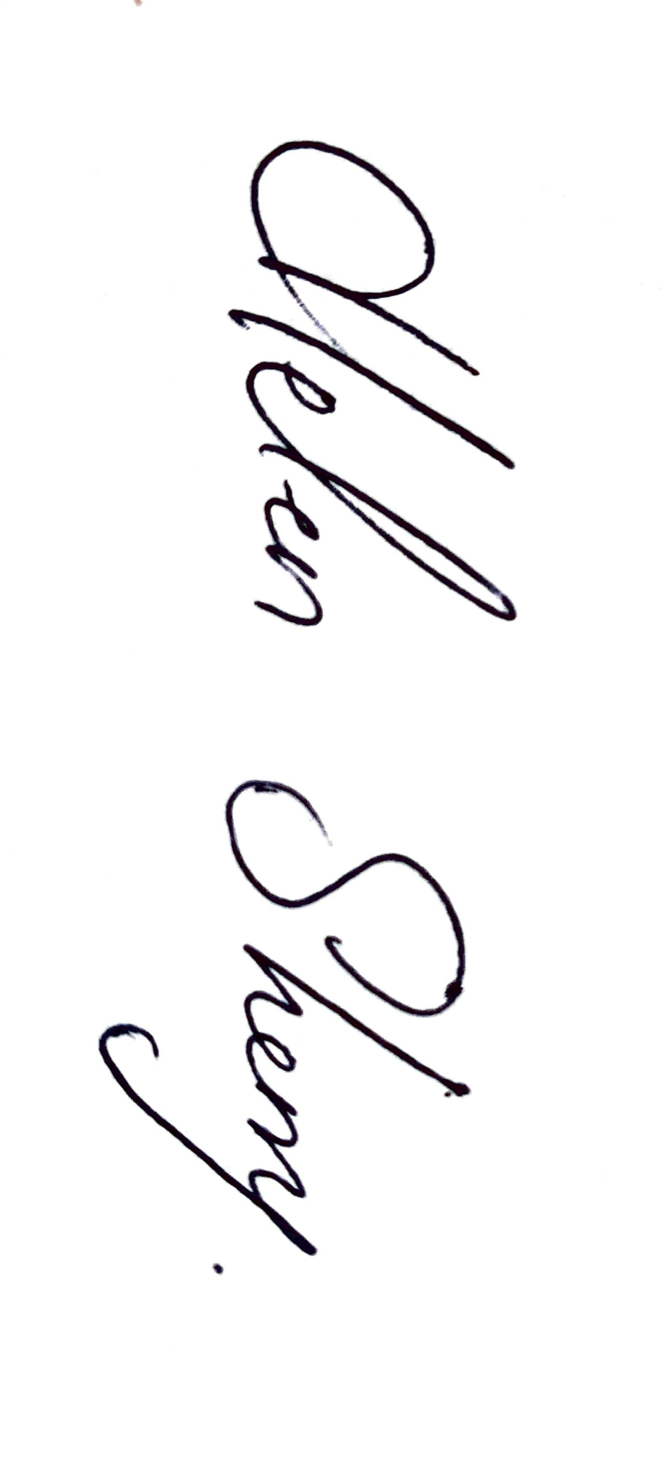
This policy and its implementation will be reviewed, following input from our school community, each calendar year or as soon as practicable after there has been a material change in any matter to which this policy refers.

Signed: 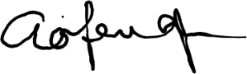 Signed:
Chairperson of Board of Management Principal/Secretary to the Board of Management

Date: 19th June 2025 Date: 19th June 2025

Appendix 1
Determining if bullying behaviour has occurred

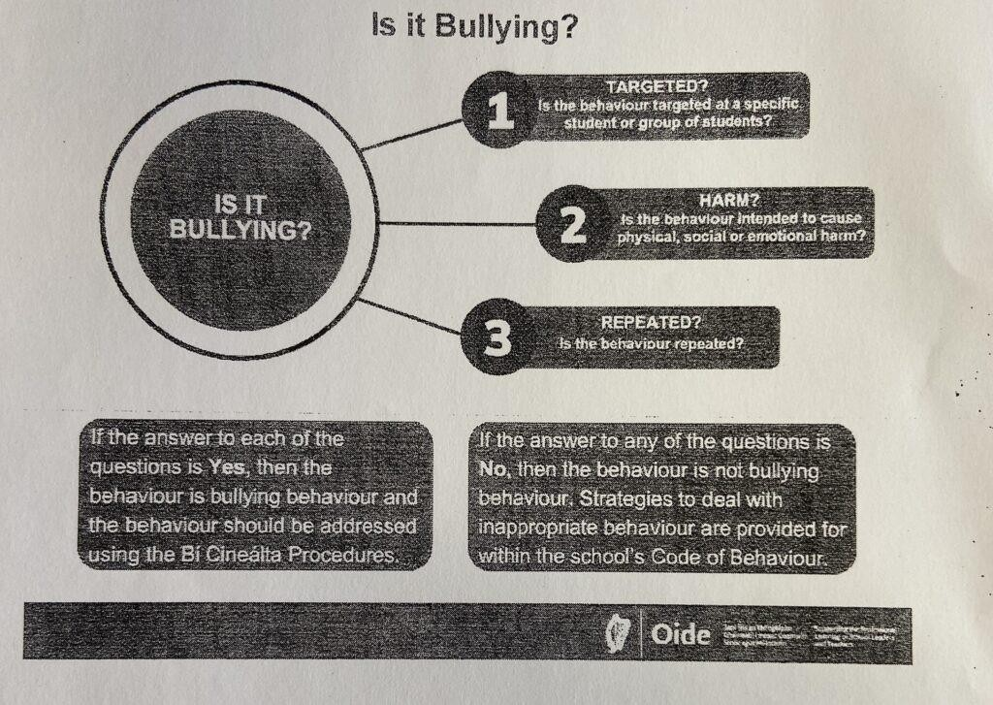

Date
Source of
concern
Actions taken,
e.g. investigations
Outcome of
actions

Monitoring template for max 5/10-day period
Date | Record of events

Appendix 2

Record and Adress Bullying Behaviour; Review; Cease bullying ( 2,3,4)

Background

Name of student experiencing bullying behaviour Class
Name and class of students engaging in bullying behaviour

Form of bullying

Direct Bullying | Indirect Bullying | Online Bullying
Physical | Exclusion
Verbal | Relational
Written
Extortion

Type of Bullying

Disablist |  | Racist
Exceptionally able |  | Poverty
Gender identity |  | Religious identity
Homophobic/transphobic/LGBT  Q+ |  | Sexist
Physical appearance |  | Sexual harassment
Other

Location of bullying behaviour ( add date)

Inside school (outside space, classroom, other)
Outside school (to/from school;
other)

Record of initial engagement

 | Date consulted | Method of Consultation
School Staff
Students
Parents

Actions to be taken agreed

- ___________________________________________________________________________

- ___________________________________________________________________________

- ___________________________________________________________________________

Views of students and parents on agreed actions to be taken to address the bullying behaviour

Date: |  | Date:
Experiencing bullying |  | Engaging in bullying
Student |  | Student
Parent |  | Parent

Follow up; Review; Cease bullying

The teacher must engage with students and parents again no more than 20 days after the initial engagement.

Consider:
- Nature of bullying behaviour
- Effectiveness of strategies used to address bullying behaviour
- Relationship between the students involved

Views of students and parents: has the bullying behaviour ceased?

Date: |  | Date:
Experiencing bullying |  | Engaging in bullying
Student |  | Student
Parent |  | Parent
If not included in the above, what date has it been determined that the bullying behaviour has stopped _______________.
If bullying behaviour has not ceased, the teacher reviews the strategies used in consultation with the students involved and their parents. They agreed to a time frame for further engagement until the behaviour has ceased.

Actions to be taken agreed:

- ​

- ​

Views of students and parents on agreed actions to be taken to address the bullying behaviour
Date: |  | Date:
Experiencing bullying |  | Engaging in bullying
Student |  | Student
Parent |  | Parent

Other actions may include:

Engagement with external services/supports
Ongoing supervision
Support needed for the students involved
Disciplinary sanctions as per PBP (private matter!!)
If parents not satisfied, refer to Complaints
procedure
If parents not satisfied with above, refer to
Ombudsman for Children

Appendix 3

Guide to Providing Bullying Behaviour Update for Board of Management Meeting

Having reviewed the details of the incidents of bullying behaviour that have been reported since the previous board of management meeting, the principal must provide the following information at each ordinary meeting of the board of management:

Total number of new incidents of bullying behaviour reported since the last board of management meeting.

The total number of incidents of bullying behaviour currently ongoing.

A total number of incidents of bullying behaviour have been reported since the beginning of this school year.

Where incidents of bullying behaviour have been reported since the last meeting, the update must include a verbal report which should include the following information where relevant:

- the trends and patterns identified such as the form of bullying behaviour, type of bullying behaviour if known, location of bullying behaviour, when it occurred etc.
- the strategies used to address the bullying behaviour > any wider strategies to prevent and address bullying behaviour
- if any serious incidents of bullying behaviour have occurred which have had a serious adverse impact on a student
- if a parent has informed the school that a student has left the school because of reported bullying behaviour
- if any additional support is needed from the board of management
- if the school’s Bí Cineálta policy requires urgent review in advance of the annual review this update should not include any personal information or information that could identify the students involved.

