Child Safeguarding Statement and Risk Assessment


Child Safeguarding Statement

Cuan na Gaillimhne CNS is a primary school providing primary education to pupils from Junior Infants to Sixth Class.
In accordance with the requirements of the Children First Act 2015, Children First: National Guidance for the Protection and Welfare of Children 2017, the Addendum to Children First (2019), the Child Protection Procedures for Primary and Post-Primary Schools (revised 2023) and Tusla Guidance on the preparation of Child Safeguarding Statements, the Board of Management of Cuan na Gaillimhne CNS has agreed the Child Safeguarding Statement set out in this document.

- The Board of Management has adopted and will implement fully and without modification the Department’s Child Protection Procedures for Primary and Post-Primary Schools (revised 2023) as part of this overall Child Safeguarding Statement

- The Designated Liaison Person (DLP) is Helen Sherry

3.The Deputy Designated Liaison Person (Deputy DLP) is Margit Mularkey

4. The Relevant Person is Helen Sherry
(The relevant person is one who can provide information in respect of how the child safeguarding statement was developed and will be able to provide the statement on request. In a school setting the relevant person shall be the designated liaison person.)

- The Board of Management recognises that child protection and welfare considerations permeate all aspects of school life and must be reflected in all of the school’s policies, procedures, practices, and activities. In its policies, procedures, practices and activities, the school will adhere to the following principles of best practice in child protection and welfare:

The school will:
- recognise that the protection and welfare of children is of paramount importance, regardless of all other considerations.
- fully comply with its statutory obligations under the Children First Act 2015 and other relevant legislation relating to the protection and welfare of children;
- fully co-operate with the relevant statutory authorities in relation to child protection and welfare matters;
- adopt safe practices to minimise the possibility of harm or accidents happening to children and protect workers from the necessity to take unnecessary risks that may leave themselves open to accusations of abuse or neglect;
- develop a practice of openness with parents and encourage parental involvement in the education of their children; and
- fully respect confidentiality requirements in dealing with child protection matters.

The school will also adhere to the above principles in relation to any adult pupil with a special vulnerability.
- The following procedures/measures are in place:

- In relation to any member of staff who is the subject of any investigation (howsoever described) in respect of any act, omission or circumstance in respect of a child attending the school, the school adheres to the relevant procedures set out in Chapter 7 of the Child Protection Procedures for Primary and Post Primary Schools (revised 2023) and to the relevant agreed disciplinary procedures for school staff which are published on the gov.ie website.

- In relation to the selection or recruitment of staff and their suitability to work with children, the school adheres to the statutory vetting requirements of the National Vetting Bureau (Children and Vulnerable Persons) Acts 2012 to 2016 and to the wider duty of care guidance set out in relevant Garda vetting and recruitment circulars published by the Department of Education and available on the gov.ie website.

- In relation to the provision of information and, where necessary, instruction and training, to staff in respect of the identification of the occurrence of harm (as defined in the 2015 Act) the school-

- Has provided each member of staff with a copy of the school’s Child Safeguarding Statement
- Ensures all new staff are provided with a copy of the school’s Child Safeguarding Statement
- Encourages staff to avail of relevant training.
- Encourages Board of Management members to avail of relevant training.
- The Board of Management maintains records of all staff and Board member training.

- In relation to reporting of child protection concerns to Tusla, all school personnel are required to adhere to the procedures set out in the Child Protection Procedures for Primary and Post Primary Schools (revised 2023), including in the case of registered teachers, those in relation to mandated reporting under the Children First Act 2015.

- All registered teachers employed by the school are mandated persons under the Children First Act 2015.

- In accordance with the Children First Act 2015 and the Addendum to Children First (2019), the Board has carried out an assessment of any potential for harm to a child while attending the school or participating in school activities. A written assessment setting out the areas of risk identified and the school’s procedures for managing those risks is included with the Child Safeguarding Statement.

- The various procedures referred to in this Statement can be accessed via the school’s website, the gov.ie website or will be made available on request by the school.

Note: The above is not intended as an exhaustive list. Individual Boards of Management shall also include in this section such other procedures/measures that are of relevance to the school in question.
- This statement has been published on the school’s website and has been provided to all members of school personnel, the Parents’ Association (if any) and the patron. It is readily accessible to parents and guardians on request. A copy of this Statement will be made available to Tusla and the Department if requested.

- This Child Safeguarding Statement will be reviewed annually or as soon as practicable after there has been a material change in any matter to which this statement refers.

This Child Safeguarding Statement was adopted by the Board of Management on 15th September 2025.
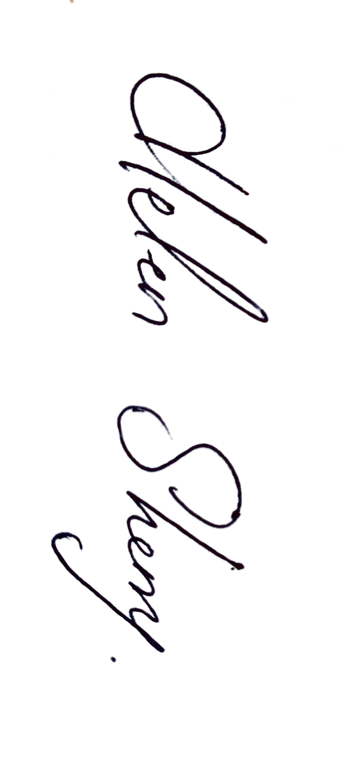
This Child Safeguarding Statement was reviewed by the Board of Management on 15th September 2025

Signed: 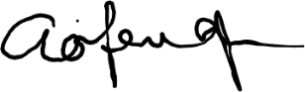 Signed:
Chairperson of Board of Management Principal/Secretary to the Board of Management

Date: 15th September 2025 Date: 15th September 2025

Child Safeguarding Risk Assessment
Written Assessment of Risk of Cuan na Gaillimhne CNS
In accordance with section 11 of the Children First Act 2015 and with the requirements of Chapter 8 of the Child Protection Procedures for Primary and Post Primary Schools (revised 2023), the following is the Written Risk Assessment of Cuan na Gaillimhne CNS.

List of School Activities | Risk  Level | The school has identified the following Risk of Harm | The school has the following Procedures in place to address risk identified in this assessment
Training of school personnel in Child Protection matters | High | Harm not recognised or reported promptly | Child Safeguarding Statement & DES procedures made available to all staff.  The child protection Procedures for Primary & Post Primary Schools (revised 2023) are made available to all school personnel.  DLP & DDLP to attend PDST face to face training All Staff to view Túsla training module & any other online training offered by PDST.  BOM records all records of staff and board training
One to one teaching including sensory room | Med | Harm by school personnel | Child Safeguarding Statement & DES procedures made available to all staff.  The child protection Procedures for Primary & Post Primary Schools (revised 2023) are made available to all school personnel.  One to One teaching Policy Plan
Care of Children with special needs, including intimate care needs | High | Harm by school personnel | Policy on intimate care
Toilet areas | High | Inappropriate behaviour | Usage and supervision policy
Curricular Provision in respect of SPHE, RSE, Stay safe. | Med | Non-teaching of same | School implements SPHE, RSE, Stay Safe in full
Daily arrival and dismissal of pupils | Low | Harm from older pupils, unknown adults on the playground | Arrival and dismissal supervised by Teachers

List of School Activities |  | The school has identified the following Risk of Harm | The School has the following Procedures in place to address risk identified in this assessment
Managing of challenging behaviour amongst pupils, including appropriate use of restraint | High | Injury to pupils and staff | Restraint Policy  Health & Safety Policy  Code Of Behaviour
Use of external personnel to supplement curriculum | Med | Harm to pupils | Policy & Procedures in place for external teaching facilitators and teachers  Vetting
Students participating in work experience | Med | Harm by student | Work experience Policy  Child Safeguarding Statement  Vetting
Recreation breaks for pupils | High | Harm to student by student | Adequate supervision
Outdoor teaching activities | High | Harm to children | Adequate supervision.  Forest School Policy  Outdoor Activity Statement for Parents
Swimming | High | Harm by school personnel, pool staff or others | Ensure school staff are familiar with pool before first visit with the school.  Assign staff specific points of supervision to ensure children cannot leave changing area alone.  Parents who volunteer to help with swimming are garda vetted.
School outings using private bus company | High | Harm to children | Adequate school staff supervision
Administration of Medicine  Administration of First Aid | High | Harm to child by school  personnel | First Aid administered in specific area in front of window of door Two children together in buddy system when one is getting first aid for a minor issue otherwise in line with the Intimate Care Policy
Training of school personnel in child protection matters | High | Harm not recognised or reported promptly | Child safeguarding statement and DES procedures made available to all staff.  DLP & DDLP to attend PDST face to face training.  All staff to view Túsla training module and another other online training offered by PDST.  BOM records all records of staff and board training.

List of School Activities |  | The School has identified the following Risk of Harm | The school has the following Procedures in place to address risk identified in this assessment
Care of pupils with specific vulnerabilities/ needs such as  ∙ Pupils from ethnic minorities/migrants ∙ Members of the Traveller community ∙ Lesbian, gay, bisexual or transgender (LGBT) children  ∙ Pupils perceived to be LGBT  ∙ Pupils of minority religious faiths ∙ Children in care  ∙ Children on CPNS (Child Protection Notification System) | Med | Harm not recognised or reported promptly | R.S.E. Policy  S.P.H.E. Policy  Anti-bullying policy
Recruitment of school personnel including -  ∙ Teachers  ∙ SNA’s  ∙ Caretaker/Secretary/Cleaners  ∙ Sports coaches  ∙ External Tutors/Guest Speakers ∙ Volunteers/Parents in school activities ∙ Visitors/contractors present in school during school hours.  ∙ Visitors/contractors present during after school activities | High | Harm not recognised or properly or promptly reported | Child Safeguarding Statement & DES procedures made available to all staff.  Staff to view Tusla training module & any other online training offered by PDST.  Vetting Procedures  Policy of Parents / Volunteers  Policy on Visiting Contractors  Access via intercom to people who are identified and met on stairs
Bullying | Med | Harm to children by children | Anti-Bullying Policy  Code of Behaviour
Use of video/photography/other media to record school events | High | Harm not recognised or properly or promptly reported | Photography policy
Forest school | High | Harm to child | Forest school policy
Social media | High | Potential for bullying  Potential for grooming of pupils | Anti-bullying policy  Teachers are legally obliged to teach the  Stay Safe Programme.

Important Note: It should be noted that risk in the context of this risk assessment is the risk of
“harm” as defined in the Children First Act 2015 and not general health and safety risk. The definition
of harm is set out in Chapter 4 of the Child Protection Procedures for Primary and Post-Primary
Schools (revised 2023)

In undertaking this risk assessment, the board of management has endeavoured to identify as far as possible the risks of harm that are relevant to this school and to ensure that adequate procedures are in place to manage all risks identified. While it is not possible to foresee and remove all risk of harm, the school has in place the procedures listed in this risk assessment to manage and reduce risk to the greatest possible extent.

