

Cuan na Gaillimhe CNS
- a Steiner educatiOn

An Cimín Mór, Cappagh Road Knocknacarra, Galway, H91Y38E Roll No: 20462d Tel: (091) 867 387
www.cuannagaillimhecns.ie

Complaints Procedure Policy
1 INTRODUCTION
The Board of Management of Cuan na Gaillimhe CNS has adopted the Complaints Procedure, agreed by the teachers' union and management bodies, which provides a mechanism for dealing with parental complaints against a teacher as set out in Section 28 of the Education Act 1998.
2 RELATIONSHIP TO SCHOOL ETHOS
The school promotes positive home - school contacts and endeavours to enhance the self-esteem of everyone within the school community. The policy contributes towards those ideals.
3 AIMS/OBJECTIVES
- To foster fruitful and trusting relationships between school and parents
- To afford parents an opportunity to express opinions/grievances through the framework of a defined procedure
- To minimize the opportunity for conflict by providing parents an opportunity to liaise with the class teacher.
4 INTRODUCTION
Only those complaints about teachers which are written and signed by parents/guardians of pupils may be investigated formally by the Board of Management, except where those complaints are deemed by the Board to be:
- matters of professional competence and which are to be referred to the Department of Education & Science
- frivolous or vexatious and which do not impinge on the work of a teacher in a school
- complaints in which either party has recourse to law or to another existing procedure.

Unwritten complaints not in the above categories may be processed informally as set out in Stage 1 of this procedure.

STAGE 1

  - A parent/guardian who wishes to make a complaint should approach the class teacher/ special education teacher with a view to resolving the complaint.
  - Where the parent/guardian is unable to resolve the complaint with the class teacher/special education teacher she/he should approach the Principal Teacher with a view to resolving it.
  - Where the complaint is still unresolved the parent/guardian should raise the matter with the Chairperson of the Board of Management with a view to resolving it.

STAGE 2

  - If the complaint is still unresolved and the parent/guardian wishes to pursue the matter further she/he should lodge the complaint in writing with the Chairperson of the Board of Management.
  - The Chairperson should bring the precise nature of the written complaint to the notice of the teacher and seek to resolve the matter between the parties within 5 days of receipt of the written complaint.
STAGE 3

  - If the complaint is not resolved informally, the Chairperson should, subject to the general authorisation of the Board and except in those cases where the Chairperson deems the particular authorisation of the Board to be required:
- Supply the teacher with a copy of the written complaint; and
- Arrange a meeting with the teacher and, where applicable, the Principal teacher with a view to resolving the complaint. Such a meeting should take place within 10 days of receipt of the written complaint.

STAGE 4

  - If the complaint is still not resolved the Chairperson should make a formal report to the Board within 10 days of the meeting referred to in 3.1 (b)
  - If the Board considers that the complaint is not substantiated the teacher and the complainant should be so informed within 3 days of the Board meeting.
  - If the Board considers that the complaint is substantiated or that it warrants further investigation it proceeds as follows:
- The teacher should be informed that the investigation is proceeding to the next stage;
- The teacher should be supplied with a copy of any written evidence in support of the complaint;
- The teacher should be requested to supply a written statement to the Board in response to the complaint;
- The teacher should be afforded an opportunity to make a presentation of the case to

the Board. The teacher would be entitled to be accompanied and assisted by a friend at any such meeting;
- The meeting of the Board of Management referred to in (d) and (e) will take place within 10 days of the meeting referred to in 3.1 (b)

STAGE 5

  - When the Board has completed its investigation, the Chairperson should convey the decision of the Board in writing to the teacher and the complainant within 5 days of the meeting of the Board.
  - The decision of the Board shall be final.

In this policy 'days' means school days. Complaints made by parents against other staff members will be dealt with by the BOM in a similar manner.
5 SUCCESS CRITERIA
    - Swift and efficient resolution of grievances
    - Parent/Teacher satisfaction
    - Positive school community feedback
    - Reviews of school policies as issues arise.

6 IMPLEMENTATION AND REVIEW

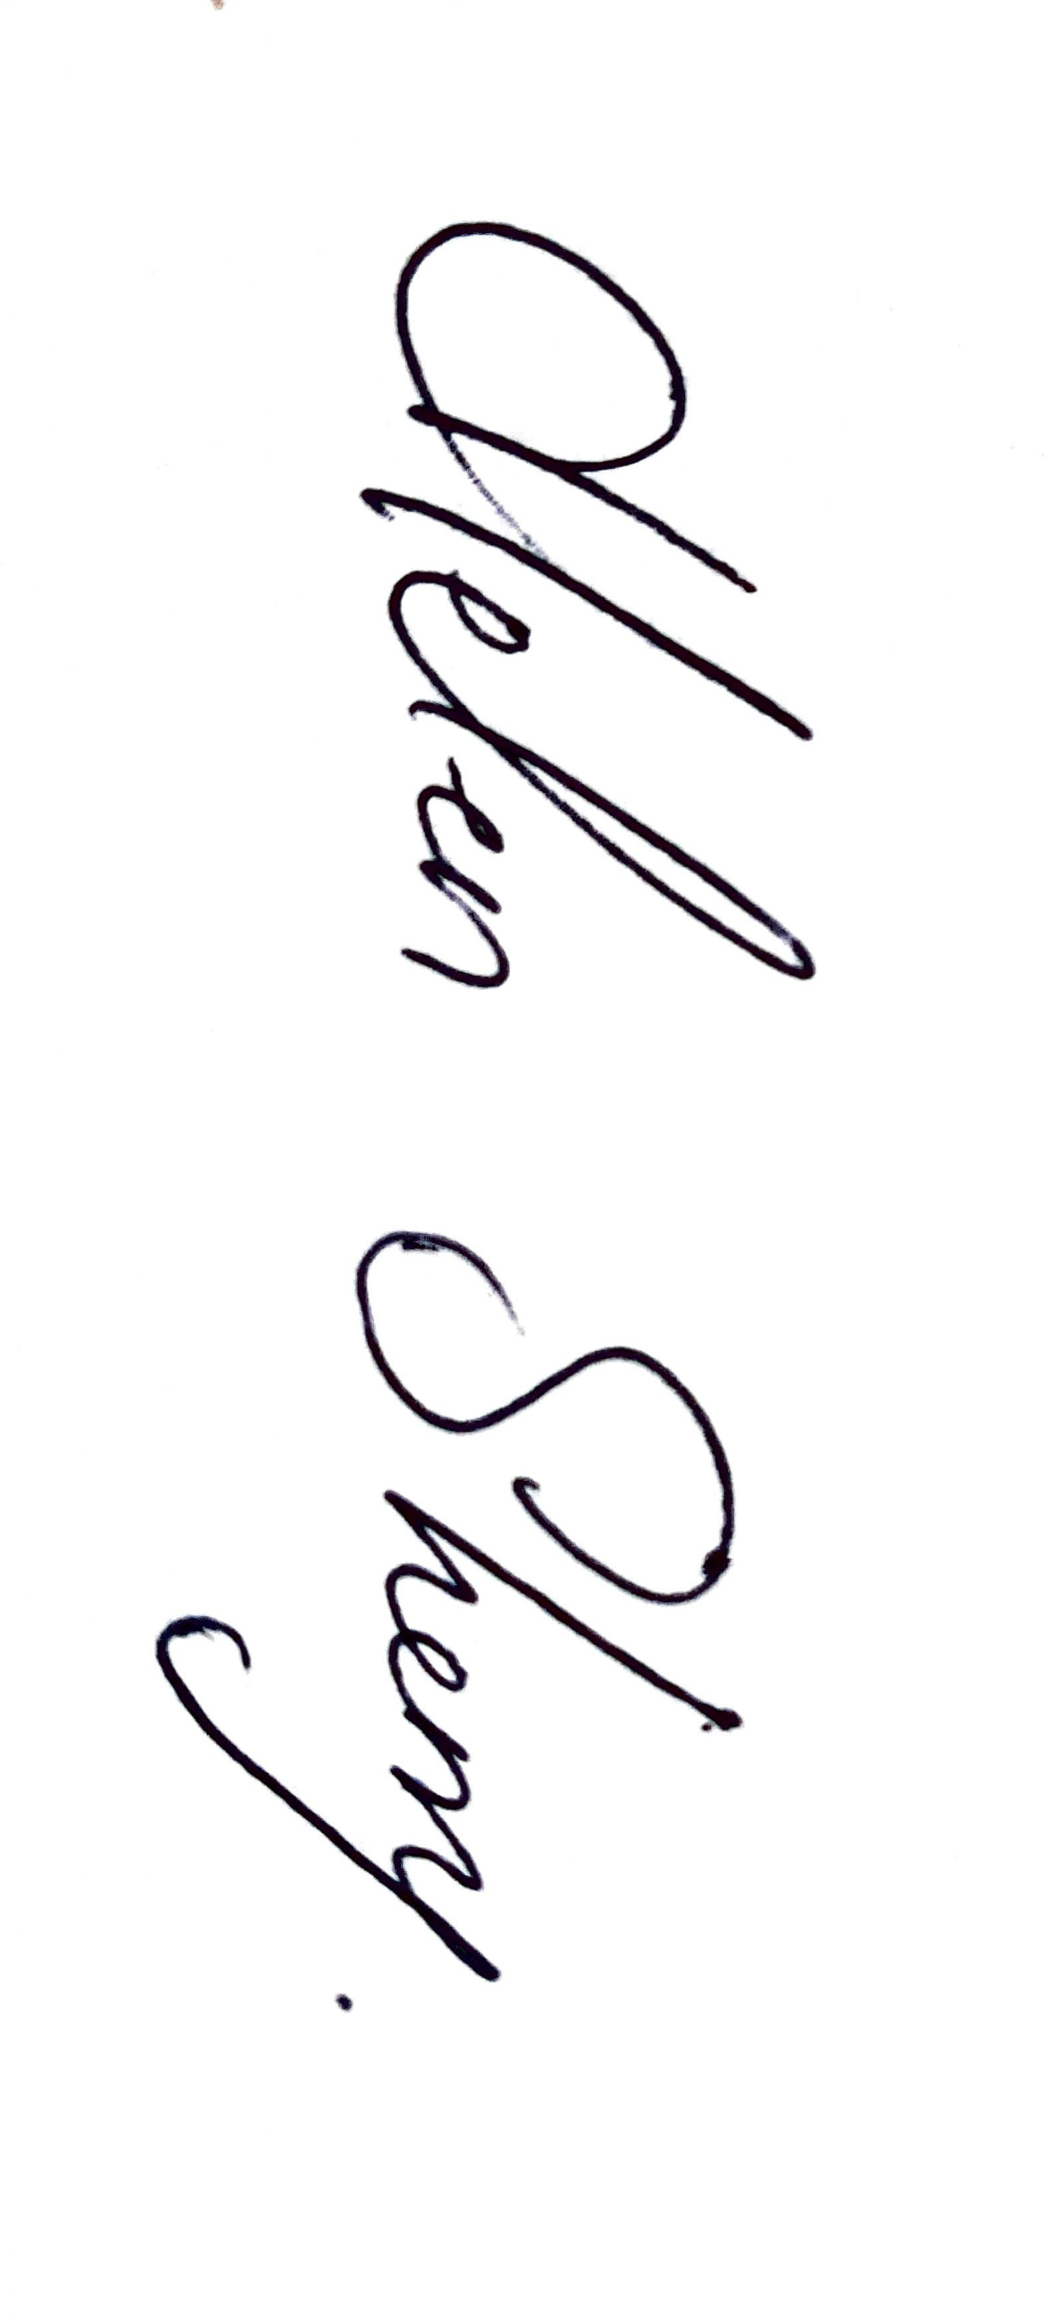
This policy was ratified by the Board of Management of Cuan na Gaillimhe CNS on the 14 June 2016 and reviewed on the 11th of February 2019. This policy has been reviewed on the 12th May 2025

Signed: 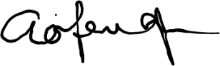 Signed:
Chairperson of Board of Management Principal/Secretary to the Board of Management

Date: 12th May 2025 Date: 12th May 2025

