

Cuan na Gaillimhe Community National School- A Steiner Education
New Family Welcome Booklet
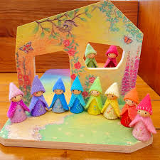
We are a multi-denominational Community National School using Steiner pedogeological methods to deliver the Irish national curriculum. We opened in September 2015 and have grown by one class per year. We had our first 6th class in 2022.
We are a multi denominational, co-educational, child centred national school. We believe that education is best achieved in a warm and joyful environment where children are actively engaged in the learning process.
Through our rich arts approach, we cultivate knowledge, creativity and practical skills. The Irish primary curriculum is delivered in an integrated and developmentally appropriate way with a strong emphasis on movement, music, art, handwork, drama and outdoor learning.
The holistic development of each pupil is nurtured to foster in them the self-confidence and resilience necessary to take their place in the community as creative, well balanced and responsible people.
We are the first Steiner National School in Galway, and we opened in Knocknacarra in September 2015 under the patronage of Lifeways Ireland, the patron body of Irish Steiner schools. On August 29th, 2019, Galway and Roscommon Education and training board (GRETB) became our new Patron Body. The new arrangement helped provide a framework of support for the school while maintaining the Steiner pedagogy in the school. Lifeways Ireland continues to advise the school in relation to Steiner pedagogy.
The school will deliver the Irish Department of Education’s curriculum in accordance with the Steiner Waldorf Pedagogy. It is subject to the Department of Education's rules for National Schools governing the curriculum, class sizes, teacher appointments, training and recruitment. The school is run by the teachers and overseen by the Board of Management. Parental involvement is extremely important, and all parents and guardians will automatically part of the Parent Teacher Association (PTA) which promotes the interests of the students in the school in co-operation with the Board. Elections for committee members for the PTA will take place once a year.
Steiner Education
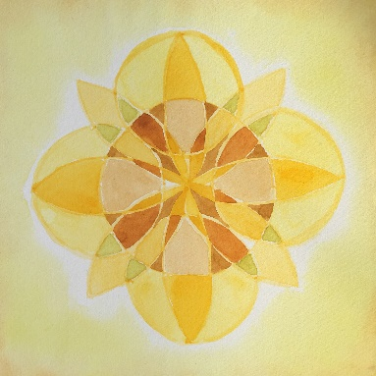
Steiner Education is a child-centred education that seeks to nurture ‘the hand (willing), the heart (feeling)and the head (thinking)’ of every child. It is a holistic, child centred pedagogy that:
- Is co-educational, multi-denominational, democratic and committed to cultural diversity and social equality.
- Emphasises natured based play and education, strengthening the child’s connection to nature. Develops a love of learning and an enthusiasm for school
- Sees artistic activity and the development of the imagination as integral to learning.
- Takes account of the needs of the whole school-academic, physical, emotional and spiritual.
- Delivers the Irish curriculum, but in a creative and integrated way.
- Prioritises age-appropriate learning, adapting its teaching methods to suit the developmental stage of it’s pupils, as well as their experience of the world
Source: Pearse O Shiel, Chairman of Lifeways Ireland

FESTIVALS
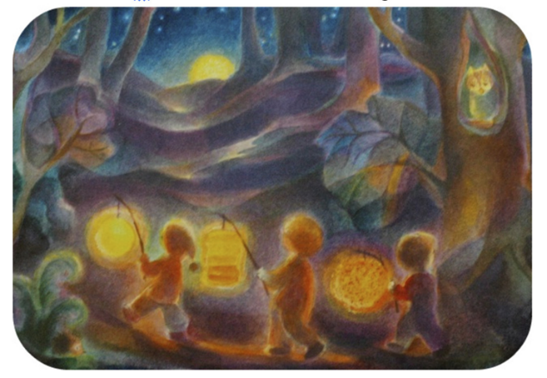
The celebration of festivals is an important part of the school year in Steiner Waldorf Schools. Just like the flow of activities through the day and the week, our school year follows a dynamic rhythm inspired by the change of nature throughout the seasons. Festivals are the anchor points of the yearly rhythm. Stories, songs and crafts, learned over a few weeks in school, build up the specific atmosphere to a festival. Parents are often invited to share in festival celebrations with their children. It has been proven that parental input into school life helps children to grow in confidence and parents are strongly encouraged to become involved in diverse aspects of school life to make their child’s schooling a memorable time. If you have some time to spare and can help us to develop the school community at Cuan na Gaillimhe CNS, please let us know!
Autumn is celebrated with Michaelmas on September 29th. St. Michael is known as the conqueror of the dragon, the heavenly hero with his starry sword (cosmic iron) who gives strength to people. This festival, that usually brings a Harvest Table to the school, marks the season when we start turning inward after the long warm days of Summer and gather up strength and fortitude to face the colder days and long nights of the Winter ahead.
In November we celebrate Martinmas. The traditional symbol for the Martinmas festival is the lantern. The lantern is the symbol of our own light which we can shine on the dark world, and we celebrate the festival with a lantern walk in Barna Woods.
Christmas: An ancient festival; celebrated when the sun sends the least power to the Earth, we celebrate the light and out human abilities to share with each other through festive activities. We create and Advent Spiral which symbolises finding light in the darkness. It is a time when the souls withdraw into the innermost depths to experience within itself the inner spiritual light.
In February, Spring comes to our school with St. Brigid and Candlemas. April leads us to Easter which derives its name from pre-Christian goddess symbols of rebirth, fertility and Spring. The renewal of man’s is celebrated with that of the Earth. Ancient symbols the Hare and egg are both known as signs of the return of life after Winter’s sleep.
In Nay we celebrate the May Festival with a Maypole dance and a fair to celebrate warmth, joy and growth.
On the 24th of June as school draws to a close, we have St. John’s Festival in Rinville Park, Oranmore, to celebrate the Midsummer Day: Ancient peoples, watching the sun reach its high point at this time, lit bonfires to encourage it to shine and ripen their crops. It is a time when the cosmos brings the spiritual to man-a time when the spiritual, which animates and weaves through everything in nature, is revealed.

DROP OFF AND COLLECTION POINTS
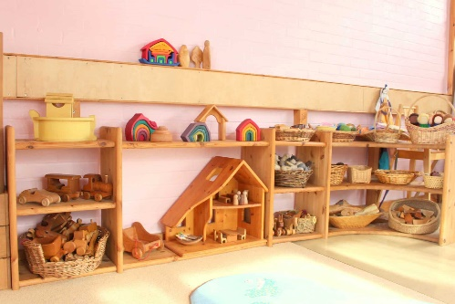
Drop off point
Infants
Infant children are to be dropped off up at the school where they will be met by their teacher.

1st Class Onwards
Parents are welcome to drop their child to the classroom any day, but from 1st class onwards children can also proceed themselves to their classroom.

Collection Point
All children will walk with a teacher to the front gate of the school at the end of each day, where they will go home with a parent guardian.
We ask that parents are punctual at collection time. Children who are not collected will return to the school grounds (office, staff room) under the supervision of school staff. Upon arrival parents must sign the book to confirm late collection. Please note that this time is used for teacher planning, meetings, etc. and we ask for your co-operation in collecting your children in a timely manner. It can also be stressful for a young child if parents are late.
Late arrival is not a reason for driving onto school grounds as there are still children from The Educate Together present at this time.

COLLECTION BY SOMEONE OTHER THAN A PARENT/GUARDIAN
Children can be collected at the school gate by an adult known to the school, as arranged by parents/guardians.
However, if for any reason, you are not comfortable with the arrangement, please email the office and collection will be as communicated to school only.
If an unknown adult is collecting your child, this must be communicated to the office before 12:30pm on the day of collection. For safety reasons we still ask the adult to make themselves known to the class teacher to ensure the safety of your child.
Collection arrangements should be made in good time to avoid upset to children and interruptions to school day.
LATE ARRIVALS/EARLY DEPARTURES
The official start to the school day is 9:10am. There is a 10-minute grace period from 9:10am –9:20am as the children arrive. Children arriving after 9:20am are marked as late on the roll.
Roll call in our school takes place at 9:30am. Please let the office know if your child arrives after 9:30am to ensure they are recorded on the Roll. This can be done by email to info.cng@gretb.ie or by reminding your child to call into the office on their way to class and let the secretary know they have arrived.
PARENT – TEACHER RELATIONSHIPS
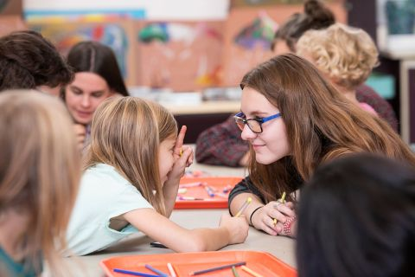
If you have a concern relating to your child, you should first speak to your class teacher about your concern. If this is not satisfactory, please talk to the school Principal. All appointments can be made through the school secretary using info.cng@gretb.ie. If, after that, you need to take it up further, you are welcome to bring your concern to the Board of Management.
A parent teacher meeting is held in the first term, when teachers report on the child’s progress. A formal written report will be sent at the end of the school year. There will be other occasions throughout the year when parents will be invited to find out more about what the children are learning.
We also welcome as much informal contact as possible. If your child has any difficulties, please let your teacher know immediately. Please respect that class starts at 9:10am and finishes at 2:50pm (1:50pm for infants) and make an appointment outside theses times.
We rely on the active involvement of all families in contributing some time and practical skills to enable the school to function properly.
ILLNESS AND ABSENCES
Parents are asked not to send their child to school when they are sick. It is vitally important that you inform the school of any on-going medical condition that your child may have. Please also inform the school if your child has a contagious illness, including headlice so that parents can be informed of symptoms. This will be treated with sensitivity (your child will not be named).
The school should be notified of absences as soon as possible, with a brief explanation of the reason for the absence. The school is happy to accept absence notes by email info.cng@gretb.ie. The school is obliged to report to the TUSLA Educational Welfare Officer when a child has been absent for twenty days in a school year. This includes all absence days including sick days. An emergency contact number should be supplied so that parents/guardians can be contacted during the day, should an emergency arise. Please therefore, inform the school immediately of any changes in the emergency contact number you provided.

FIRST AID
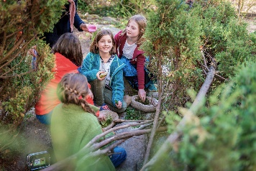
From time-to-time minor incidents such as cuts and abrasions etc. Will occur. The staff at the school will deal with these by washing the cut, cleaning with an antiseptic and if necessary, applying a plaster.
Please complete the permission slip for basic First Aid to be administered to your child. If for any reason you do not want us to treat cuts etc. Please state this clearly on the form. You will then be contacted at home or work if your child needs attention.
ADMINISTRATION OF MEDICINES
The Board of Management requires that parents inform their child’s teacher in writing of any medical condition their child may have. While the Board of Management has a duty to safeguard the health and safety of pupils when they are engaged in authorised school activities, this does not imply a duty upon teachers to personally undertake the administration of medicines. The administration of medicines can be discussed with the class teacher in line with the school’s medical policy.
CLOTHING
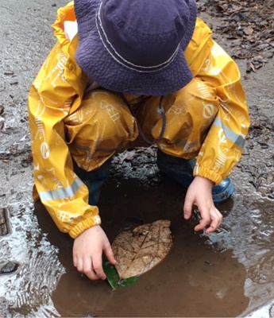
Children at Cuan na Gaillimhe CNS are not required to wear a school uniform. It is, however, very important that your child is properly equipped for the various school activities.
Clothes should be plain and comfortable. For the children’s comfort, as well as for environmental reasons, we recommend natural materials such as cotton and wool. Clothing should be dignified, non-distracting (no characters etc. and appropriate for all possible school activities. Your child will need a set of rain gear and wellies for Summer, and a waterproof ski suit of fleece lined wet gear and snow boots or lined wellies for Winter.
Being outside is part of our day:
Hats required all year round. In the Summer your child is required to wear sunscreen on arrival to school and bring a bottle of sunscreen in his or her bag along with a sunhat.
Please be aware of the importance of warmth for the growth and wellbeing of children and consider that at the amount of time spent outdoors during school activities, insufficient clothing is a serious strain for children.
Painting smock
Please send one adult sized t-shirt you no longer need which can be used during painting activities.
Please label all items of clothing with your child’s name. This saves a lot of time and helps your child, and their teacher keep track of clothing.
Please provide the school with a spare bag of changing clothes. This is always required to minimise distress at the time of toileting accidents and to have a general change of clothes if clothes get wet. This bag will be kept on your child’s hook. Please make sure this is refilled when wet clothes are sent home.
LITTLE BIT ON WHERE TO BUY.
TIPS AND HINTS FOR DREEING YOUR CHILD
LITTLE THINGS THAT HELP
Here are some small things that are a big help
- Send in an adult sized t-shirt to keep our clothes clean during Art.
- Ensure your child is dressed appropriately according to the weather.
- Ensure your child has a spare change of clothes in school at all times, and refill it when wet clothes are sent home.
- Pack the cutlery needed with your child’s snack/lunch
- It is a parent/guardian’s responsibility to report absences to the school. Please ensure all absences are reported to the school by phone, or preferably by email info.cng@gretb.ie
- Like our Facebook page
- Arrive at school on time in the morning and for collection time.
- Label, label, label!!! All clothing, bags, lunch boxes and bottles.
PARENT TEACHER ASSOCIATION
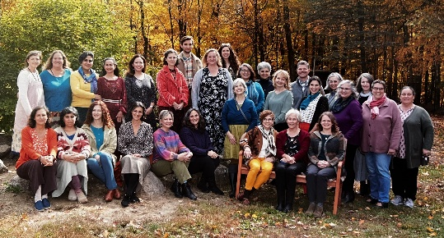
We really encourage you to play an active role in our Parent Teacher Association. We have a very active and wonderful Parent Teacher Association. We have our AGM in September, and you are very welcome to come. They help set up a class WhatsApp group to share information with you on school related and relevant things. You would be very welcome to join the committee, and everyone is part of the PTA.

LOCATION AND PARKING

- Parking information
- When you enter the school gates, walk up on the left of the other school. We are in the prefabs up the back.
- Parking is not available on the school grounds. The area outside the school is reserved for drop off and collection. However, you can park outside the school from 9:15am-1:00pm for periods not exceeding 10 minutes.
CONTACT US
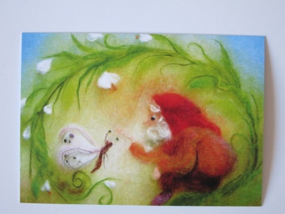
An Cimín Mór
Cappagh Road
Knocknacarra
Galway
H91 KX30
PHONE: 091 867 387
EMAIL: info.cng@gretb.ie
Website: cngcns.com

Principal: Helen Sherry
Designated Liaison Person for Child Protection: helen.sherry@gretb.ie
Chairperson of the Board of Management: Aoife Neylon

Helpful Information on Steiner Education

Child Development

Thinking, Feeling, & Willing
At its core thinking, feeling, and willing can be described as ways we each relate to the world. And as a result, the ways we learn something or learn anything new.
Thinking, Feeling, Willing is a universal grouping that can apply to several areas of life:
- 3 stages of childhood
- 3 steps toward taking action
- 3 views of the world (thinkers, feelers, body-informed people)
It’s embedded in our development but also shows up in how we interact with the world and how we see the world. Thinking, feeling, and willing is really an archetypal framework that gives us a window into the world of being human from three fundamental perspectives, three ways of navigating life. And so, when we want to nurture and educate the WHOLE child, this framework or perspective can be really helpful.
These three human activities all relate to the body. Thinking relates to the head, feeling to the rhythmic organs in the torso (such as the heart and lungs), and willing, or doing, relates to the limbs.
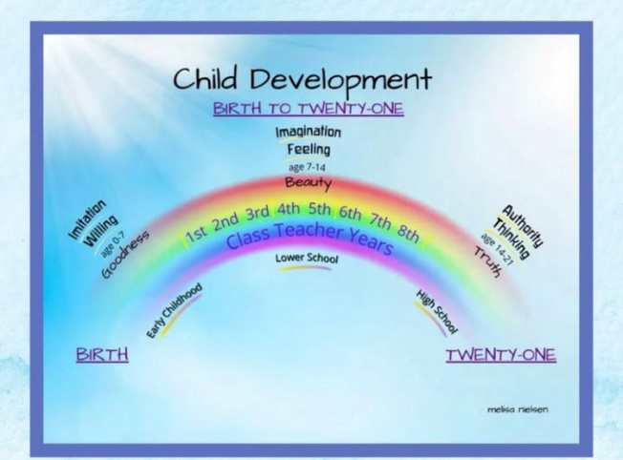

The order of these three activities as we engage with the world around us varies depending on our age. This is what Rudolf Steiner called the “child’s changing consciousness.” Children are not just little adults. They see and interact with the world differently than we do. And when we weave these ideas into how we teach children, we awaken their capacities in a much fuller and livelier way.
“Understanding that children need to be engaged in these three distinct ways, through head, heart, and hands, forms the primary educational paradigm at a Waldorf school. Rather than focus the education work solely around the objective of acquiring knowledge, creating a meaningful learning process itself becomes the focus. Through multi-faceted, multi-sensory learning experiences, teachers and students use a variety of intelligences to develop three distinct capacities – for thinking, for feeling, and for intentional, purposeful activity.” ~Jack Petrash

How Our Children Change & Grow

Birth to Age 7
In the early years ~ from birth to about age 7 ~ children learn primarily through their will or their limbs, and their activity. They learn by doing.
Young children often watch other children or the adults around them doing something, and then they try it themselves. Or they hear a story and then want to set up a little scene and pretend to build the house or cut down the tree.
So, at this stage, the order of the three ways of engaging with the world is willing, then feeling, then thinking. Young children first do something, which generates a feeling, and then they have thoughts about the scenario. They primarily engage through their limbs – their hands and legs – by doing. They need to do something with what they were taking in about the world.

Ages 7 to 14
Between the ages of 7 and 14, children learn primarily through their feelings. When they encounter something new, they first have a feeling about it. The feeling often inspires action and then they have a thought about that. Or they have a feeling, then thought, and then act. The feeling comes first.
This is why during these years we incorporate a lot of rhythm (relating to the heartbeat) and teach through the lively arts. That is, through story, drawing, painting and modelling, movement and music, speech and drama. Because the arts awaken our heart forces. They allow us to feel deeply, to relate to others, to care.

Ages 14 and Up
As children get older ~ over the age of 14 and into the adult years ~ they learn primarily through their thinking. These are the years when the head is the predominant force. Teenagers and adults like to read and discuss and consider.
So, the order of these fundamental perspectives during this phase of life is thinking, feeling, and then willing. We think about something or learn something new, then we have a feeling, and then we act.

Balancing Thinking, Feeling, & Willing
Here are some wonderful things that Steiner, Piaget, and Vygotsky all agree on and ways they have influenced education:
- Children often learn best by doing things rather than hearing about them. When children discover something for themselves, they often remember that experience in a deeper, more meaningful way.
- The process of learning is as important or even more so than the result or product of the learning. Process over product.
- Children can’t learn something they aren’t ready to learn. The stages of child development matter when we consider teaching and learning.

Finding Balance
By inviting children to start in the early years with willing, then feeling in the middle years, and finally thinking in the teen years, this approach allows a child to develop all these aspects of their being so that their head, heart, and hands are all awakened.
Our goal is really to harmonize these three ways of interacting with the world: thinking, feeling, and willing.
I want to leave you with a beautiful verse from Rudolf Steiner.

The Four Temperaments

"The temperaments alone make all multiplicity, beauty and fullness of life possible.” – Rudolf Steiner

Does your child have boundless energy, saying everything at top volume? Or is your child often lost in daydreams? Maybe you have a social butterfly, who skips and hops from one interest to the next.

While many different factors influence our children’s personalities, there are some traits they seem to be born with. This is the idea of temperament, a set of characteristics that are part of our intrinsic natures.

In Waldorf education, Rudolf Steiner used the concept of the four temperaments, first conceptualized in ancient Greece, as one way to understand children, and meet their needs. Steiner elaborated on these ideas and taught them to the first Waldorf teachers.

Waldorf teachers continue to use this framework today. It may influence seating plans, storytelling, main lessons, and more. As parents, seeing your child through this lens may give you new insights.

However, Waldorf teachers understand that temperament can and does shift over time. “We don’t hold the children firmly in one temperament. Even if they show some dominance, we know that it is likely to change when they get to be nine and older,” explained Mima Djordjevic, Sunrise Kindergarten Teacher. “They are tendencies, they don’t really define us.”

The Four Temperaments Explained
In this model, there are four main categories, each linked to an element – earth, air, fire, and water. They are sanguine (air), choleric (fire), melancholic (earth), and phlegmatic (water).

We all have each of the four temperaments. Steiner believed adults should work to harmonize the temperaments in themselves.

In his book, The Four Temperaments: Suggestions for Teachers, Helmut Eller explains some people may have as many as three predominant temperaments. So, even though we discuss temperament as though children fall neatly into categories, none of them do. Their personalities are unique, and they may show different temperaments in different situations.

Let’s look at each temperament, and (with Eller’s help) start to understand them.

Sanguine (Air)
Sanguine children are usually happy and carefree. They are said to love beautiful things and bright colours and are the most social of the temperaments.

Eller describes them in this way: “Light and cheerful, spontaneous and confident, she openly approaches new situations … She makes new friends easily. She is quick to discover something new about her teacher, suddenly remembers all the things she wanted to tell him, bubbles over with the news — then runs away and hands out her birthday invitations. The sanguine child loves the world and other people and would like to embrace everyone.”

Choleric (Fire)
Choleric children are full of energy and intensity. They have strong wills and quick tempers.

Here is what Eller has to say about them: “A choleric child leads the way, constantly strives forward and energetically pursues her goal! Once it is achieved, she immediately seeks a new one! Determination and drive go hand in hand! We can sense something forceful, energetic, quick-witted, vigorous and decisive! Sheer willpower! Firm goals are set and forcefully pursued! You get the impression whatever she plans will be carried out tenaciously and thoroughly!”

Melancholic (Earth)
Melancholic children tend to be cautious and take a measured approach. They are also very sensitive and feel things deeply.

Here is how Eller sees them: “He feels much more at home in his inner world — in his thoughts, emotions and even dreams. He loves inner and outer peace and quiet and behaves sensitively and tactfully. He doesn’t like bothering other people, which is why he usually keeps to himself. He is a master of self-control and self-criticism. He therefore observes others closely and is capable of suffering deeply with them. His great assets are his ability to think things through seriously and to sympathize and empathize with others.”

Phlegmatic (Water)
Children with more phlegmatic tendencies tend to be inwardly directed, like the melancholic children, but are dreamier and more contented.

Here are Eller’s thoughts: “He experiences things sentimentally and, whenever possible, comfortably and cozily as well, because he encounters the world around him with a feeling of well-being at his own leisurely, unhurried pace. Nothing can get him worked up. He particularly relishes everything that has to do with regularity and rhythm, which is why he can spend a lot of time doing things he enjoys. His great assets are patience, endurance, calmness and peacefulness. He would never insult anyone. He enjoys situations that make him feel good and has no desire to change them.”

Are any of those personalities familiar? If not, it may be helpful to think of your child in different situations to see if any patterns arise.

The Temperaments at Home
Each temperament has its advantages and disadvantages. For example, phlegmatic children are easy-going, but can become too inactive. Choleric children are born leaders, but their quick tempers can be challenging for them to manage.

Ms. Mima said, “We help them to develop and change. We help them to balance.”

Here are some ideas from Steiner, Eller, and Ms. Mima on how to work with each temperament at home.

Sanguine (Air)
According to Steiner, sanguine children are most inspired by their love of parents or teachers. He said, “Everything must be done to awaken love in such a child. Love is the magic word.”

Since sanguine children can be distractible, Steiner recommended helping them find greater focus by supporting them in one special interest. In regard to subjects that don’t hold the children’s focus as long, he suggested introducing them to the children for a little while, then removing them until the children are interested again.

Ms. Mima advises parents to help their more sanguine children stay focused too. “Let’s say they decide to do baseball, then they want to do soccer, you should encourage them to stick with something a little longer.”

A recommendation from Eller:
• Increase their attention spans by looking closely at an object of interest together (a picture, for example), and pointing out details they might have missed.

Choleric (Fire)
Steiner believed that choleric children would best engage with the adults in their lives through respect. “For the choleric child one must be thoroughly worthy of esteem and respect in the highest sense of the word.” Choleric children want to know their elders are knowledgeable and in control.

Steiner advised adults to stay calm and collected in the face of a choleric child’s anger. “With the choleric child, try to become inwardly apathetic, to watch coolly when he has a temper tantrum.”

Ms. Mima recommends helping more choleric personalities to appreciate others’ needs. For example, telling a child, “It’s important that other people have a chance to choose the game or decide where to go.”

Other recommendations from Steiner:
• Give them challenges to work through.
• Make sure they get plenty of exercise.
• Show them your talents and skills.

Melancholic (Earth)
Since melancholic children can be too inwardly focused, especially on their own suffering, Steiner recommends helping them focus on the needs of others.

He said, “The melancholic child is capable of suffering, of moroseness. These qualities exist in him, and we cannot flog them out, but we can divert them. Above all we must show the melancholic child how people can suffer.” This could mean listening sympathetically to a complaint about a hurt your child received on the playground, and then reminiscing about a time you got stitches at the same age.

Ms. Mima advised, “Give them comfort and compassion. Hold them and say, ‘I know that must hurt, but it will get better. Our bodies know how to get better.’” She explained it’s important to do this with a sense of lightness, instead of becoming too wrapped up in the child’s problem.

Other recommendations:
• Encourage melancholic children to actively help others. (Eller)
• Ask them challenging questions. (Steiner)
• Set aside time each day to talk to them about any subject they want. (Eller)

Phlegmatic (Water)
Where Steiner thought sanguine children would be most influenced by love for an adult, he thought phlegmatic children would do best when connected to other children. “He must have playmates with the most varied interests.” He saw this as a way to help them become more active and engaged with the world around them.

Parents, then, should give phlegmatic children plenty of opportunities to make friends, and have play dates.

“Phlegmatic children can sometimes be overlooked because they don’t cause problems, they go with the flow,” said Ms. Mima. She went on to explain that phlegmatic children sometimes forget to look out for their own interests. She advises parents to help these children advocate for themselves.

Other recommendations from Eller:
• Create a calm and stable home environment.
• Allow them extra time to get ready in the mornings.
• Ask them questions at regular intervals to keep them engaged.

The Temperaments Enrich Our Lives
Even though each temperament can present its own unique set of challenges, and as Steiner wrote, they also make life full and beautiful. As you journey through life with your children, enjoy them, and their unique personalities.

Morning Practice

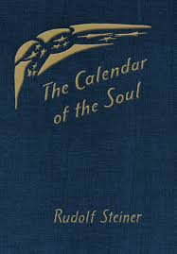
In listening to the changing language of the year, said Rudolf Steiner, we can rediscover our individual nature. These meditative verses, one for each week of the year, help to awaken a feeling of unity with nature while simultaneously stimulating a discovery of the self. Through intensive work, Steiner's unique meditations can lead to a feeling of oneness with the world. We use this every morning in our Morning Meditations with the Teachers.

Each morning recite the verse of the week from this book.

This week verse is:
Nature, your essence motherly,
I bear within the being of my will;
And my will’s fire-force,
It steels impulses of the spirit,
So they may bear a sense of self
To bear myself in me.

Evening Practice

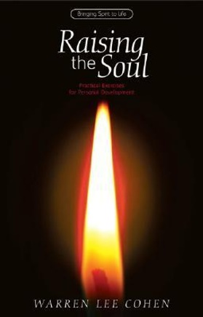

Review of the day
Steiner would highly recommend that every evening before sleeping you review your day by going backwards in your day and noting all you did from the moment you are lying in bed backwards to the morning. The intention is to release and let go of the day but also to prepare us for the review of our life when we return. Warren Lee Cohen explains this practice and more in this wonderful book I highly recommend called “Raising the Soul”.

You can do this with your child before going to sleep as part of your bedtime routine as well as your own practice for reviewing your day.

Another ritual could be the rose, the bud and the thorn reflection at the end of your day. The rose is an experience or moment in your child’s or your day that you enjoyed, felt connected, was memorable. The thorn is the moment in the day that was challenging or where you did not feel connected. The bud is your intention for the next day or something you learned or some wisdom you wish to take to other future experiences.

These two practices or rituals that help and support you & your child’s start and completion of your day.

Why do we celebrate festivals in our school?

This was a recent question asked by a parent…

Festivals are very important in our school; the celebration of festivals acknowledges the cycle of the year and lies at the heart of our school. Children experience festivals not only as special days, but as a season for which there is time for preparation and a time for letting go.

Because young children live so fully in the world that surrounds them, festivals primarily focus on nature’s changing processes.

These festivals are celebrated through stories, fables, music and drama. We are a multi-denominational setting and families from all religious or non-religious backgrounds are welcome. There are opportunities to celebrate festivals within the familiarity of the class. The class teachers introduce the children to poems, songs, stories, crafts etc. appropriate to the season. The children prepare for the festivals by making crafts and learning new songs.

Parents get involved in the festival preparations and celebrations, offering a chance to meet and share. Here is a look at all the festivals and their underlying intention and meaning.

Harvest Fetsival
Michaelmas is celebrated as the “festival of strong will”. In the autumn, at harvest season, there is the transition from the outer warmth of summer to the coolness of winter. We turn inwards, towards ourselves and towards our community for inner warmth. The meaning behind this celebration is about finding the confidence and courage to look to the spiritual world for strength and renew the impulse to live our lives to the best of our abilities. In the tradition, Michael represents the unconquered hero, fighting against the dragon and the power of darkness. He is a model for valour and courage. The primary idea behind the festival of Michaelmas is to get children to face their own challenges – their dragons! This festival is used to teach children the importance of using courage to prepare for the colder, darker, winter months.

LANTERN FESTIVAL
Martinmas is celebrated with a traditional lantern walk in the spirit of Martin who represents hope and compassion. The light from the lantern signifies the carrying on of the light that was started with the season of Michaelmas, and which gets brighter as we approach the darker days of winter, representing the strengthening of our inner light while nature sleeps. The essence of this festival is to acknowledge the light that shines from each of us. This light needs to be protected, just as the lights inside our lanterns.

WINTER SOLSTICE FESTIVAL
Advent is the period of preparation for Christmas, characterised by a sense of anticipation. Through stories, poems and songs the teacher’s guide the children to experience a settling down, a feeling of being blanketed for a winter nap. The fallen leaves, the animals in hibernation, the shorter daylight hours, which bring us inside much earlier than at other times of the year, all contribute to this experience. Advent balances the darkness and sleepiness with expectation and anticipation. It is a time of moving through the darkness toward the light when finally, the days begin to grow longer. Advent is a four-week festival, the four weeks leading up to Christmas and Winter Solstice. It is celebrated as a special occasion to bring warmth and light to Winter days. It is a lovely event to watch – in a darkened room, a spiral path is laid out in greenery with a large candle in its centre. Each child carries their own candle in an apple along the spiral path, lights it from the main flame and sets it down within the spiral on their golden star and gradually the room fills with light.

MAY DAY FESTIVAL
May Day is celebrated to welcome the beautiful summer season and the longer days. Known as Bealtaine in the Celtic tradition, May Day is a popular and ancient tradition of celebrating the arrival of summer. We greet the new warm season by wearing garlands and flower crowns. It is tradition to dance around the Maypole while singing joyful summer songs. The Maypole bears colourful ribbons and symbolises the tree of life and growth of summer vegetation. We gather as a community with food to share in this abundance.

John’s festival
John’s Festival is directly after the Summer Solstice and is a celebration of the return of the sun and light. We dance around the fire, make bread on a stick, sing songs and play together. This usually takes place in Renville Park.

Pedagogical Stories
Pedagogical stories are short, purposeful stories used to teach, support, or address specific challenges children may face. They’re often tailored to help children understand emotions, navigate social situations, or build confidence. These stories provide relatable characters and scenarios, offering insights and strategies that children can internalise. They’re particularly effective because they present lessons in a gentle, engaging, and non-judgmental way. The trick is to read it once a day and don’t discuss it afterwards, let it peculate in the child’s soul and preform its alchemy as it is. Here are some samples for children feeling different emotions…

A Pedagogical Story for a Child Feeling Anxious
"Max and the Worry Cloud"
Max was a little fox who loved to explore the forest. He loved playing hide-and-seek with his friends, chasing butterflies, and climbing trees. But sometimes, out of nowhere, a Worry Cloud would show up and follow him around.
It wasn’t a big storm cloud—just a small, grey puff that hovered above his head. But to Max, it felt heavy. The Worry Cloud would whisper things like, “What if you mess up?” or “What if everyone laughs at you?”
One morning, Max was getting ready for a big forest race. His friends were so excited, but Max could feel the Worry Cloud creeping closer. “What if I’m too slow? What if I trip and fall?” Max whispered to himself, looking at the starting line.
Max’s best friend, Lila the rabbit, noticed him sitting by himself. “Max are you okay?” she asked.
Max sighed. “I have this Worry Cloud, and it keeps telling me I’ll mess up. I don’t think I can race.”
Lila thought for a moment. “You know, I get a Worry Cloud too sometimes. But I found a trick that helps.”
“What’s that?” Max asked, his ears perking up.
“I talk to it,” Lila said. “I say, ‘Thank you for trying to protect me, but I’m okay. I’m going to try my best, and that’s enough.’ Then I take a big breath and imagine the cloud floating away.”
Max tilted his head. “Does it work?”
Lila smiled. “It might not go away right away, but it gets smaller. And when I focus on having fun, it usually disappears.”
Max decided to give it a try. He stood up, looked at his Worry Cloud, and said, “Thank you for looking out for me, but I’m going to run this race. I’ll try my best, and that’s enough.” Then he closed his eyes, took a deep breath, and imagined the Worry Cloud getting smaller and smaller.
When the race started, Max felt the wind in his fur and heard his friends cheering. He didn’t come in first, but he didn’t trip, and no one laughed. In fact, Max realised he had a great time running with his friends.
As they all celebrated, Max glanced up. The Worry Cloud was gone.
This story can help an anxious child see that their worries are normal, manageable, and not a permanent part of their experiences. It encourages self-talk, deep breathing, and focusing on fun rather than fear.

Pedagogical Story for children who feels a lot of anger and frustration

"Leo and the Volcano Inside"
Leo’s Big Feelings
Leo was a little lion cub who lived in the sunny savannah. He was brave and playful, but sometimes, when things didn’t go his way, he felt like a volcano was bubbling inside him.
Like the time his tower of rocks fell over. Or when his little sister took his favourite ball. Or when he didn’t win at hide-and-seek. Each time, Leo’s cheeks would get hot, his paws would clench, and—BOOM! He would roar, swish his tail, and sometimes even knock things over.
One day, after he swiped at his best friend Zuzu the zebra during a game, Zuzu said, “Leo, I like playing with you, but when you hit or roar at me, it hurts my feelings.”
Leo’s ears drooped. He didn’t want to hurt Zuzu. “I don’t mean to,” he said softly. “It’s just… it feels like a volcano is inside me, and it explodes before I can stop it.”
Zuzu thought for a moment. “I get volcano feelings too sometimes. Want to know what helps me?”
Leo nodded.
The Cooling Trick
“When I feel my volcano bubbling, I do three things,” Zuzu explained. “First, I stop and say, ‘Volcano, I see you.’ Then, I take a big, deep breath—like this.” Zuzu closed her eyes, filled her chest with air, and slowly let it out. “And then, I stomp my hooves on the ground or shake my tail to let out the fizz. It’s like letting the volcano steam out slowly so it doesn’t explode.”
Leo tilted his head. “Does it really work?”
“It takes practice,” Zuzu said, “but it helps. And if you need help, you can always talk to a friend or a grown-up lion.”
Leo Tries
The next day, Leo was playing with his little sister. She accidentally knocked over his block tower, and he could feel the volcano start to bubble.
“Volcano, I see you,” Leo said, just like Zuzu taught him. He stopped, took a deep breath, and then stomped his paws softly on the ground. Slowly, the bubbling feeling got smaller, and the volcano didn’t explode.
“I didn’t mean to knock it over,” his sister said, looking worried.
“It’s okay,” Leo said. “Let’s build it together!”
A New Way
From then on, whenever Leo felt the volcano inside him, he remembered Zuzu’s trick. He didn’t always get it right—sometimes the volcano still erupted. But each time, he got a little better at cooling it down.
And soon, Leo realised that even when things didn’t go his way, he could handle it without roaring or hitting. That made him feel like a truly strong lion.
This story introduces a child to practical strategies for managing anger (acknowledging the emotion, deep breathing, and physical activity to release energy) in a relatable way. It also emphasises the idea that making mistakes is part of learning and growing.

A Pedagogical Story for children who feels a lot of sadness

"Ella and the Little Raindrop"
Ella’s Gray Days
Ella was a kind and thoughtful elephant calf who lived in the grasslands. Most days, she loved splashing in the waterhole, playing hide-and-seek in the tall grass, and listening to the birds sing. But sometimes, out of nowhere, a little raindrop would land on her heart.
When the raindrop was there, everything felt heavier. Even the sunshine didn’t feel as bright, and playing with her friends seemed too hard. Ella didn’t know why the raindrop came or how to make it go away. She just felt sad.
One day, her wise grandmother, Nana, saw Ella sitting under a tree, her trunk resting on the ground. “What’s the matter, my little one?” Nana asked gently.
Ella sighed. “I don’t know. I just feel… grey inside.”
Nana nodded, her kind eyes twinkling. “It sounds like you have a little raindrop on your heart. I get those too sometimes.”
Nana’s Advice
Ella’s ears perked up. “You do? But… what do you do about it?”
“Well,” Nana said, “I learned that raindrops don’t stay forever. They’re like visitors who need a little kindness. When I feel a raindrop, I take three steps to care for it.”
“What steps?” Ella asked.
Nana smiled. “First, I name it. I say, ‘Hello, Raindrop. I see you.’ Then, I do something that makes my heart feel a little warmer, like thinking about someone I love or remembering something nice. And last, I share the raindrop with someone I trust. Talking about it helps it feel smaller.”
Ella Tries
The next day, Ella woke up with a raindrop on her heart again. It felt heavy, but this time, she remembered Nana’s words.
“Hello, Raindrop,” she said softly to herself. “I see you.” Then she thought about the time she and her best friend, Tilly the tortoise, made funny faces in the mud and laughed so hard their sides ached. That memory made her trunk curl into a small smile.
Finally, she went to find Nana. “I have a raindrop today,” she said.
Nana wrapped her trunk around Ella’s. “Thank you for sharing it with me, my sweet one. Do you feel a little lighter?”
Ella nodded. “A little.”
The Rainbow Surprise
Over time, Ella practiced Nana’s three steps whenever a raindrop appeared. Some days, the raindrop stayed longer, but Ella learned it was okay to feel sad sometimes. She also noticed something magical: when she cared for her raindrops, they didn’t feel so heavy, and sometimes, they even left behind a tiny rainbow in her heart—a reminder that she was strong enough to handle her feelings.
Ella still had grey days, but now she knew she wasn’t alone. With Nana’s help, she learned that even when the raindrops came, sunshine wasn’t far behind.
This story helps a melancholic child understand that sadness is a natural emotion, not something to fear or hide. It introduces steps like naming emotions, practicing gratitude or positive memories, and sharing feelings with a trusted person—tools that can gently empower them to navigate their sadness.

A Pedagogical Story for children who feel rebellious, defiant and stubborn

"Milo and the Stubborn Stone"
Meet Milo
Milo was a clever, adventurous goat who loved to explore the mountains. He had big ideas, strong opinions, and didn’t like being told what to do. “I’ll figure it out my own way!” he would say whenever his parents, teachers, or friends tried to guide him.
But sometimes, Milo’s determination made things harder for him. Like the time he got stuck on the narrow mountain trail, or when he refused to listen during climbing lessons and slipped on the rocks. Milo hated when things didn’t go his way, but he couldn’t help it—he didn’t like being told no.
One sunny day, Milo was walking along his favourite trail when he saw a giant stone blocking the path. It was smooth and round, much too big to jump over or push aside.
“I’ll move it myself!” Milo declared, planting his hooves firmly.
Milo’s Challenge
Milo tried everything. He pushed the stone with all his strength. He rammed it with his horns. He even tried tying a rope to the stone and pulling it. But no matter what he did, the stone wouldn’t budge.
Frustrated, Milo plopped down on the ground. “I don’t need anyone’s help,” he muttered. But deep down, he felt stuck—not just on the trail, but in his heart.
Just then, Milo’s friend Bella, a thoughtful little bird, fluttered by. “Milo, why are you sitting here?” Bella asked.
“There’s a big, stubborn stone in the way, and I can’t move it!” Milo huffed.
Bella tilted her head. “Why don’t you ask someone for help?”
Milo frowned. “I don’t need help. I can do it myself.”
Bella landed beside him. “But sometimes, even the strongest mountain goats need a little help. Asking doesn’t mean you’re not strong. It just means you’re smart enough to use all the tools you have—even your friends.”
Milo hesitated. He didn’t like asking for help. But the stone was so big, and Bella’s words stayed in his mind.
The Team Effort
Finally, Milo took a deep breath. “Okay, fine. Maybe I do need some help.”
Bella chirped happily. “That’s the spirit! Let’s go find some friends.”
Together, they asked Milo’s friends—Luna the rabbit, Theo the bear cub, and even Bella’s bird family—to join them. With everyone working together, they pushed and rolled the stone until it was out of the way.
Milo couldn’t believe it. “Wow, that was so much easier with everyone helping!”
Bella smiled. “See? You’re still strong, Milo. But sometimes, strength is knowing when to let others help you.”
A New Way
From that day on, Milo still loved to do things his own way. But he also remembered Bella’s advice: asking for help didn’t make him weaker—it made him wiser.
And though he was still a little stubborn sometimes (because that’s just who he was), Milo started to see that working with others didn’t just solve problems. It made the journey more fun.
This story encourages a defiant child to see the value of teamwork and flexibility without shaming their independence or strong will. It reinforces the idea that asking for help or listening to others doesn’t diminish their strength but adds to it.

A Pedagogical Story for children going through the Nine-Year Change
“The Journey of Leo and the Hidden Light”

Leo was nine years old, and lately, things felt different. He didn’t know why, but he was getting upset more easily. Sometimes he wanted to cry for no reason, and other times, he felt angry at his friends and family, even when they hadn’t done anything wrong. It was as if a storm was swirling inside him, and he didn’t know how to calm it.
One evening, Leo’s grandfather noticed his troubled face and sat beside him on the porch. “You know, Leo,” Grandfather said, “I once knew a boy who felt like he had lost something, though he didn’t know what.”
Leo looked up. “What did he lose?”
Grandfather smiled. “He didn’t know at first. But let me tell you, his story.”
There was once a young traveller named Leo, just like you. He lived in a village where the sun always shone, and he felt safe and happy. But one day, a strange thing happened—he started seeing shadows everywhere. Shadows where there hadn’t been any before. Some were small, some were big, and some seemed to whisper doubts in his ears.
Leo the traveller became worried. He asked the Wise Owl, “Where have all these shadows come from? They make me feel lost.”
The Wise Owl nodded knowingly. “You are growing, young one, and with growth comes new thoughts and feelings. You are starting to see the world in a new way.”
“But I don’t like it,” Leo admitted. “I used to feel safe and sure of things. Now I just feel… different.”
The Wise Owl fluffed his feathers. “That is because you are beginning a great journey. The shadows are not here to hurt you; they are here to help you find your own light.”
Leo frowned. “But what if I don’t have a light?”
The Wise Owl chuckled. “Oh, but you do! It has been inside you all along. You just need to find it.”
So, Leo the traveller set off on a quest to find his hidden light. At first, he searched outside himself—in the golden fields, in the rushing rivers, in the tallest trees. But the more he looked, the more confused he became. Where was his light?
Finally, exhausted and unsure, he sat beside a quiet lake. He stared at his reflection in the water and, for the first time, noticed something—his eyes glowed with a small but steady light. It wasn’t outside of him. It was inside him all along.
Leo the traveller returned to the Wise Owl. “I found my light,” he said. “It was inside me.”
The Wise Owl nodded. “Yes. And though the shadows will come and go, your light will always be there to guide you.”
Leo sat on the porch beside his grandfather, deep in thought. “So… you mean it’s okay that I feel different now?”
Grandfather smiled and put a hand on Leo’s shoulder. “It’s more than okay. It means you are growing. And whenever you feel lost in the shadows, just remember—you have a light inside you that will never go out.”
Leo didn’t say anything right away, but he felt a little warmer inside. The storm within him hadn’t disappeared, but maybe—just maybe—he had found a way to sail through it.
In school we use the following books for some ideas for pedagogical stories. You can also download the Rainbow Stories App, which has lovely stories to help soothe and support your child.

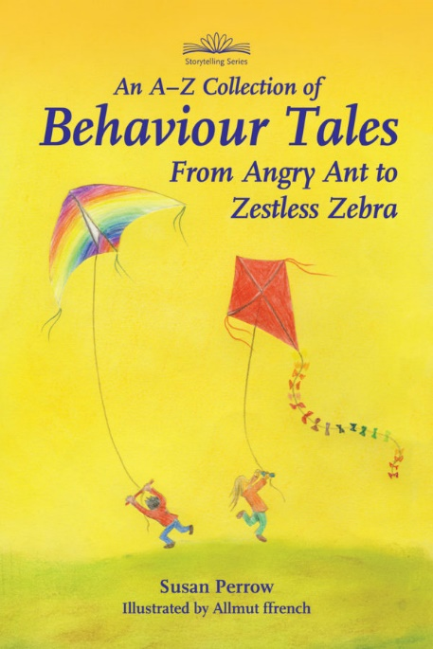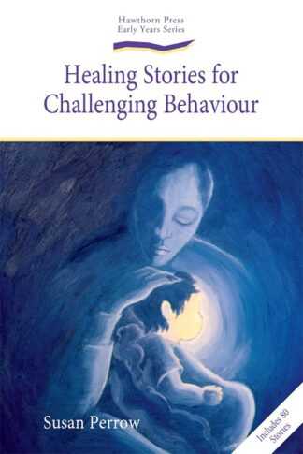

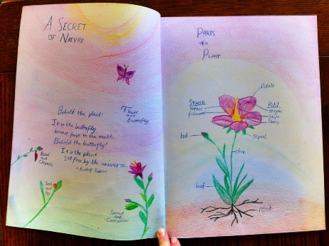
What is a Main Lesson?

A Main Lesson in a Steiner school is the central block of study each day, typically lasting 1-2 hours in the morning. It serves as a holistic approach to learning, where the teacher introduces a topic through a combination of storytelling, art, hands-on activities, and academic exploration. The Main Lesson is not just about memorising facts but about engaging the student’s imagination and emotions, allowing them to experience the subject on a deep, personal level. It is designed to cultivate the child's intellectual, emotional, and artistic being, helping them develop as whole individuals.

The Main Lessons evolve throughout the years, with themes that resonate with the developmental stages of the child. These themes provide a broad overview of human culture, nature, and the universe while being carefully attuned to each grade level's age and emotional needs.

Here is a brief outline of the themes from Infants to Sixth Class-

Junior & Senior Infants (Ages 4-6)
In infants, the focus is on creating a nurturing, rhythmic environment, as children are in the stage of imitating the world around them. There are no formal Main Lessons, but the day is filled with activities that promote physical, emotional, and social development. These activities include free play, stories, songs, puppet shows, nature walks, and seasonal celebrations. Through these activities, young children develop a sense of wonder, imagination, and connection with the natural world.

1st Class (Ages 6-7)
The Main Lesson in Class One introduces the child to the world and land of language and letter, focusing on story-based activities. The teacher will often tell stories from fairy tales, drawing out the sounds of the alphabet and shaping them into letters through artistic activities. These letters are often drawn, painted, and formed through imaginative storytelling to engage the child’s inner world.

2nd Class (Ages 7-8)
2nd Class builds on the foundations of language and introduces numbers and arithmetic in a similarly imaginative way. Children begin to learn the basics of math, often using storytelling to introduce concepts such as counting, addition, subtraction, multiplication & division. At this stage, moral tales and fables, like those of Aesop, and Myths & Legends are introduced to help the child develop a deeper sense of ethics and empathy.

3rd Class (Ages 8-9)
In 3rd Class, the Main Lesson focuses on practical life skills and the human connection to the natural world. This year emphasises subjects like farming, building/shelter, measurement and the season. Children learn through hands-on experiences, such as gardening, cooking, and construction. These practical lessons help children establish a strong connection with the physical world, grounding them in practical knowledge and life skills.

4th Class (Ages 9-10)
In 4th Class, children are beginning to experience a greater sense of individuality, and the Main Lessons reflect this shift. The focus is on local geography, animals, and mythology. Stories of Norse myths, the elements, and the natural world are explored in depth. Students also learn more advanced math, including multiplication and division. This year helps develop the child's capacity for thinking more independently and critically about the world around them.

5th Class (Ages 10-11)
5th Class delves into history and the ancient civilizations of the world, such as Ancient Egypt, India, and Greece. The child is encouraged to explore the development of human culture and civilization through storytelling, writing, and artistic work. In math, students learn more advanced concepts such as geometry and fractions. 5th Class offers an opportunity for the child to engage with human history and understand their place within it.

6th Class (Ages 11-12)
In 6th Class, students engage in a more intellectual study of the world, with a focus on geography, physics, and ancient cultures. This year often includes studying the Roman Empire and the Middle Ages, exploring topics like physics and mechanics. This is a time of expanding the child’s understanding of the world through more structured learning, with a focus on both scientific and historical inquiry.

The Main Lesson provides a rich, imaginative framework for academic development. Through the carefully chosen themes of each year group, students are encouraged to engage deeply with the subject matter, forming a strong connection with both the world around them and their inner lives. The Main Lesson blocks are designed to meet the developmental needs of the child, fostering a balanced and holistic approach to learning that supports intellectual, emotional, and artistic growth.

What do we use to deliver the Main Lesson?
The resources used to teach a Main Lesson are carefully chosen to support the holistic development of the child, addressing their intellectual, emotional, and creative needs.

Main Lesson Books
A central resource in the Waldorf Main Lesson is the Main Lesson book. Each student creates their own personalised book in which they record their learning through writing, drawing, painting, and other artistic expressions. These books are used to:

- Illustrate stories, historical events, scientific concepts, or mathematical processes.
- Write summaries, reflections, or poems based on what has been learned.
- Create diagrams, charts, or maps to visually represent the subject matter.

The Main Lesson books are both a creative outlet and an important educational tool, allowing students to engage deeply with the content and retain what they’ve learned in a meaningful way.

Artistic Supplies
Artistic materials are used across all subjects. Art supplies play a crucial role in helping students process and express their understanding of the material.

- Watercolour paints and brushes- Used for painting illustrations, visualising concepts, and even creating images inspired by stories. Watercolour painting is especially important in the early grades, helping children develop sensitivity to colour and form.
- Stockmar Coloured pencils and block & stick crayons These are used for detailed drawings, sketches, and diagrams, as well as to create vibrant illustrations that accompany the Main Lesson.
- Pastels-Often used in older grades for more detailed and precise artwork, such as in geometry lessons or to illustrate scenes from history.
- Modelling clay-Often used in early grades (1-3) for sculpting letters, numbers, or representations of animals, people, or objects from stories.

Hands On Materials
Hands-on materials are a key resource in our classrooms, especially for younger children. These materials allow students to engage directly with abstract concepts in a tangible way. Including-

- Counting beads or blocks-Used in the early years to represent numbers, solve problems, and understand arithmetic concepts. These concrete tools help children visualise and manipulate math concepts like addition, subtraction, multiplication, and division.
- Shape blocks or pattern tiles-These resources support learning in geometry, spatial relationships, and pattern recognition.
- Nature objects- For subjects like science or geography, teachers may use natural materials (such as stones, leaves, shells, or seeds) to bring concepts like plant biology or geology to life.

Story telling props
Because storytelling plays such an important role in our classrooms, teachers use a variety of storytelling props to bring the subject matter to life and engage children’s imaginations. These props include:

- Puppets- Hand-crafted puppets are often used to act out stories, particularly in the early years. Puppet shows are a way to convey moral lessons, fables, and historical narratives.
- Props from nature-Items like branches, stones, or shells may be used to represent characters or elements of a story. These materials connect children with the natural world and make the story more vivid.
- Visual aids-Teachers may use large, colourful pictures, maps, or charts to visually support storytelling and help children better understand and remember key concepts.
- Rhythmic Resources- Incorporating rhythm and movement into the Main Lesson is a key teaching method. Teachers may use various rhythmic resources to support this aspect of the curriculum, including:
- Music instruments- Simple instruments like drums, xylophones, and flutes are commonly used in the classroom. Music is often woven into lessons, with songs, chants, or rhythm exercises supporting both language and numeracy development.
- Clapping, stomping, and other body rhythms**: Teachers encourage physical rhythm exercises, such as clapping or walking in patterns, to reinforce language and math skills.
- Eurythmy-A movement-based art form unique to Steiner schools, eurythmy is often incorporated into Main Lessons. It is a form of expressive movement that helps students experience and embody the subject matter, whether it’s through rhythm, poetry, or geometry.

Literature and Handbooks
While the Main Lesson is primarily experiential and creative, students also engage with literature and reference materials. Including-

- Fairy tales and fables- Especially in the early years, teachers use fairy tales and moral stories to introduce concepts, moral lessons, and human values. For example, stories from Aesop’s Fables may be used to teach lessons about virtues like kindness, honesty, and generosity.
- Historical and cultural books-In the older classes, children study different cultures and civilizations. Teachers may use specialized literature or handbooks to provide more detailed historical, scientific, or literary background.
- Poetry and literature books- These books are often used to supplement lessons, particularly in language arts, where children are exposed to poetry, classical literature, and stories from around the world.

Blackboards and Chalk
In our classrooms, the blackboard is a fundamental teaching resource. The teacher often begins by drawing pictures, diagrams, or charts on the board to illustrate the lesson. These drawings are done in a clear, engaging way and are often filled with colour and detail. The chalkboard:
- Is used to write key concepts, sentences, or formulas.
- Provides a visual aid for students to follow along with the lesson.
- May include illustrations that tie into the story or concept being taught.

Teachers use their artistic skills to make the blackboard a vibrant part of the classroom, turning it into a living canvas that evolves throughout the lesson.

Classroom Environment
The overall classroom environment itself is an essential resource. It is deliberately crafted to be aesthetically pleasing, calming, and inspiring. Including-

- Seasonal decorations- The classroom is often decorated according to the season or a specific theme related to the lesson. This helps create a rhythmic atmosphere and reflects the connection between learning and the natural world.
- Classroom library-A carefully curated selection of books is available for independent reading and exploration, particularly in the upper grades. The library may include both fiction and non-fiction books that complement the Main Lessons.

Nature and Outdoor Resources
In our school, nature is a central theme. The outdoor environment becomes a key resource in the learning process for-

- Nature walks-Studying plant life, weather patterns, or local geography in the natural world.
- Gardening-Hands-on activities like planting and caring for a garden may be part of the curriculum.
- Outdoor play-Teachers often incorporate movement and play in nature to reinforce lessons and give children a break from seated work.

Handmade Materials
Handmade resources are integral to our educational approach because they nurture creativity, mindfulness, and personal connection to learning. These resources foster a deeper appreciation for the natural world, promote the development of fine motor skills, and encourage active engagement and imaginative exploration. By working with handmade materials, children are not only learning academic content, they also developing emotional intelligence, practical skills, and an appreciation for craftsmanship, sustainability, and the beauty of the world around them. Through these resources, we create an environment where learning becomes a deeply personal, meaningful, and holistic experience.

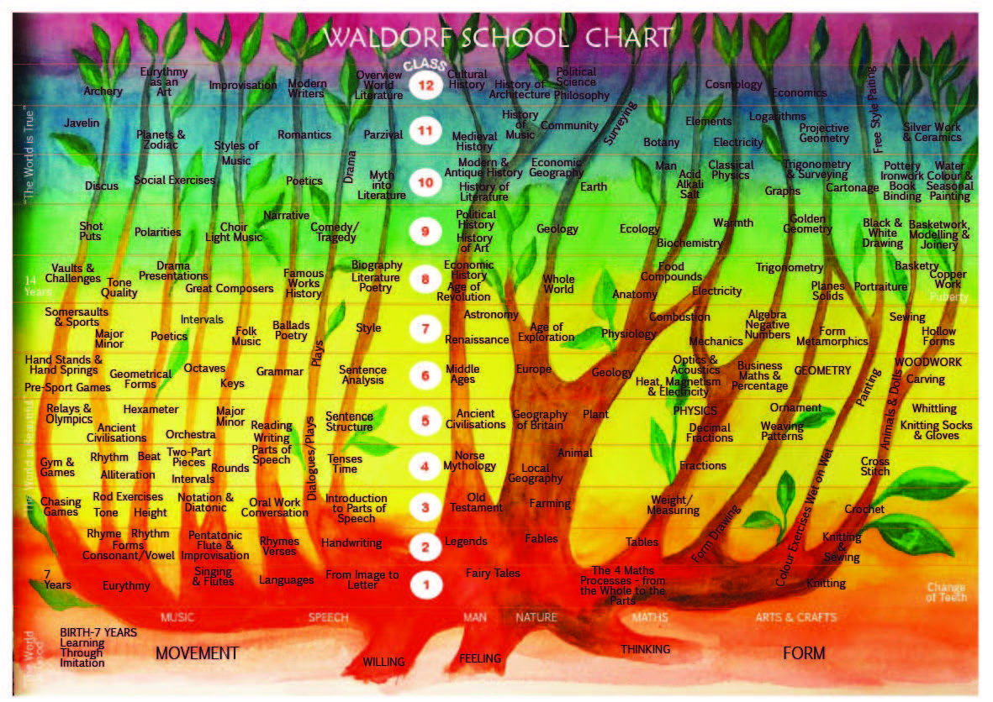

Steiner Verses
Why do we use Verses in our school?
We use verses in our daily rhythm to help create a sense of reverence, mindfulness, and connection to nature and all that is. These verses are often recited in the morning, before meals, and at the end of the day. There are also special verses for festivals, different seasons, and specific age groups.

Here are some examples:

Morning Verses

Good morning, dear Earth,
Good morning, dear Sun,
Good morning, dear rocks,
And the flowers, everyone.
Good morning, dear beasts and
And birds in the trees.
Good morning to you,
And good morning to me.

Within me lies the strength I need,
The light that guides my way.
I step into this world with trust,
To meet each dawning day.
My hands will work, my heart will shine,
My thoughts will seek what’s true,
And every deed that I shall do,
Will let the spirit through.

Verses for blessing our food
Blessings on the blossoms,
Blessings on the roots,
Blessings on the leaves and stems,
And blessings on the fruit.

Earth who gives to us this food,
Sun who makes it ripe and good,
Dear Earth, dear Sun, by you we live,
Our loving thanks to you we give.

For the sun and the rain,
For the grass and the grain,
For the toil on sea and soil,
That we may eat our daily food,
We give our thanks dear earth.

End of Day Verse
Receive the light of day,
Hold it in your heart,
Let it shine forth again,
Bright with truth and art.
My work is done,
I’ve worked with might,
And done my best,
With all my might.
Now comes the night,
And with it rest,
I close my eyes,
In peace and blessed.
The day now ends,
My work is done.
The light grows dim,
The setting sun.
I rest in peace,
And grateful be,
For all I’ve learned,
And all I see.
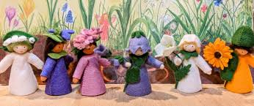
Verses for Parents
May wisdom shine through me,
May love glow within me,
May strength penetrate me,
That in me may arise
A helper of humankind,
A servant of sacred things,
Selfless and true.

Quiet I bear within me,
I bear within myself
Forces to make me strong.
Now will I be imbued
With their glowing warmth,
Now will I fill myself
With my own will’s resolve.
And I will feel the quiet
Pouring through all my being
When, by my steadfast striving,
I become strong
To find within myself
The source of strength and light.

Receive the child in reverence,
Educate the child in love,
Let the child go forth in freedom.

Birthday Verses
When I was born, the stars shone bright,
The sun smiled down with golden light.
The angels sang, the heavens played,
A child of Earth was gently laid.
Now I am (age) and shining too,
With love to give and work to do.
So bless this day, and bless this year,
And bless the path that brings me here.

The earth gave you a body,
The sun gave you its light,
The stars above your spirit,
To guide your heart so bright.
May courage, love, and wisdom,
Shine brightly on your way,
And bless you with deep gladness,
Upon your special day.

A little star shines just for me,
It’s there to guide and help me see.
It shines above to light my way,
And bless me on my special day!

Verses are a key part of daily life. They help create a sense of rhythm, mindfulness, and connection for children as they move through the school day. Reciting verses is not just about learning words, it is about nourishing the soul, fostering gratitude, and strengthening inner qualities that support lifelong learning and personal growth.

Verse for an Uncertain World

We must eradicate from the soul
All fear and terror of what comes towards us from the future.
We must acquire serenity
In all feelings and sensations about the future.
We must look forward with absolute equanimity
To whatever may come.
And we must think only that whatever comes
Is given to us by a world direction full of wisdom.
It is part of what we must learn in this age,
Namely, to live out of pure trust,
Without any security in existence.
Trust in the ever-present help of the spiritual world.
Truly, nothing else will do
If our courage is not to fail us.
Let us discipline our will,
And let us seek the awakening from within ourselves,
Every morning and every evening.
By Rudolf Steiner

Wet on Wet Painting
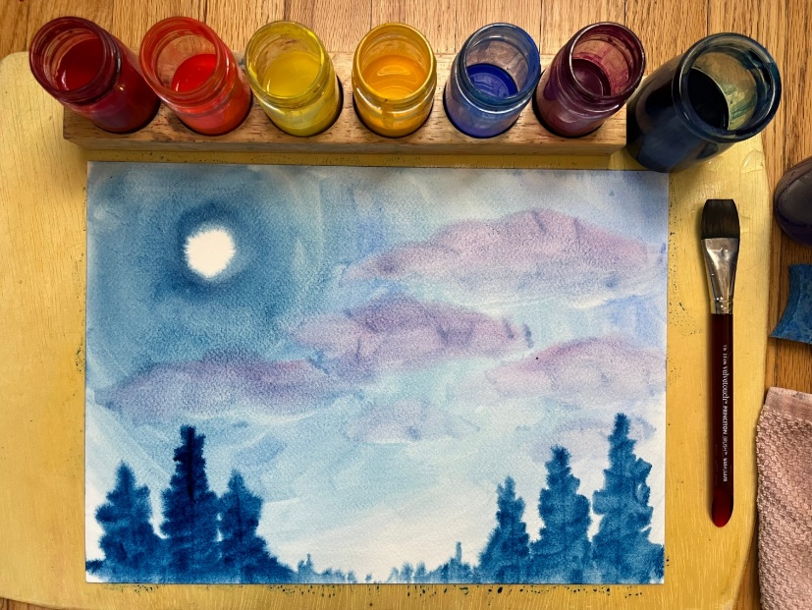

"Colour is the soul of Nature and of the entire cosmos..."
— Rudolf Steiner
Wet on wet painting is an artistic practice in our school. It is much more than just an art technique, it's a deeply intentional process that supports the developmental, emotional, and imaginative needs of our children.
Wet-on-wet painting is a watercolour technique where both the paper and the paint are wet. This allows the colours to flow, blend, and interact organically, creating soft, flowing, dream, like images rather than sharp outlines or detailed forms.
The gentle, flowing nature of wet-on-wet painting supports sensory development and helps children experience beauty in a non-verbal, emotional way. The technique invites calmness, presence, and inner quiet. It's a meditative and therapeutic process that helps children regulate emotions.
Since the technique focuses on colour and feeling rather than form, it stimulates imaginative thinking rather than analytical interpretation. It reflects Rudolf Steiner’s pedagogical understanding of how children learn in stages. In the early years, children learn best through movement, image, and feeling, not abstraction.
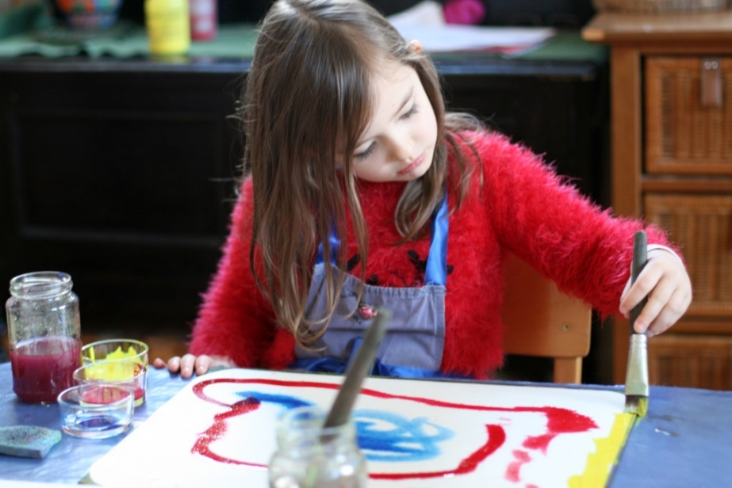
For wet-on-wet Painting, we use high-quality watercolour paper, soaked and blotted to be properly wet, stockmar watercolour paints (natural, non-toxic, vibrant pigments often diluted for softness), glass jars for mixing colours. Natural bristle brushes, typically wide and soft for smooth strokes, sponges or towels to control water on paper and boards to support the paper and catch water.
From infants, the children focus on single colours red, blue, yellow and they are introduced one at a time. Then they begin gentle colour blending by exploring what happens when two colours meet. We use stories connected to colour e.g., red for courage and introduce more deliberate compositions inspired by stories from our main lessons. Children begin shaping colour movement with intention and balancing form and colour while still letting the colours flow. They then develop greater control and layering of colour and work with shadow, contrast, and basic form while keeping the wet-on-wet softness.
“One of the best experiences of colour for the young child comes through painting with watercolours on wet paper. Colours are in their own true element in water.”
— Rahima Baldwin
Children love the freedom of expression without pressure to produce a “perfect picture, the magic of seeing colours flow, mix, and transform, the sensory joy of working with water, brush, and colour and the storytelling element each painting is often connected to a story or mood.
Wet on Wet Painting supports whole-child learning, Physical (fine motor), emotional, and imaginative parts are all engaged. It builds inner calm and focus as children often enter a flow state while painting. This painting allows a deep connection to beauty, helping develop reverence, care, and aesthetic sensitivity. There's no "right way" to paint, which supports confidence and creativity, and it encourages patience and process over product!
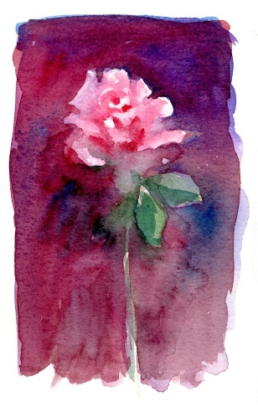
Rudolf Steiner believed that colours carry intrinsic qualities that resonate with the human soul, making them powerful tools in education and personal growth.
"Our task is to find teaching methods that continually engage the whole human being. We would not succeed in this endeavour if we failed to concentrate on developing the human sense of art." Rudolf Steiner
