

Cuan na Gaillimhe CNS
- a Steiner educatiOn

An Cimín Mór, Cappagh Road Knocknacarra, Galway, H91Y38E Roll No: 20462d Tel: (091) 867 387
www.cuannagaillimhecns.ie

Code Of Conduct

1 SELF-ESTEEM
It is recognised that self-esteem is essential to the development of every child. Cuan na Gaillimhe CNS is committed to making every effort to foster the growth of self-esteem in each and every pupil.

Parents have a vital role in this. Parents can help their children to learn and practise good behaviour and have a positive attitude towards themselves, towards other people and towards the school. It is vitally important that good behaviour be acknowledged and encouraged. Children’s development as mature, independent and strong persons depends on the quality of recognition and encouragement they get as children. Your child depends on you as parents and on us as teachers for this recognition and encouragement.
Mol an Óige agus tiocfaidh sí

2 AIMS OF THE CODE OF BEHAVIOUR
The aims of this Code of Behaviour are:
- to develop in the children a sense of self discipline and an acceptance of responsibility for their own actions;
- to create conditions for an orderly community in which effective learning can take place, in which there is mutual respect between all members, and where there is proper concern for the environment.

These are achieved in the framework of a relaxed, pleasant atmosphere, in which children are encouraged to give of their best, both in the classroom and in extra- curricular activities and are stimulated to fulfil their potential.

2.1 WHY DO WE NEED A CODE OF BEHAVIOUR?

- To make pupils aware of the necessity of good conduct.
- To make school a safe place for all.
- To encourage in all pupils respect for themselves and for others.
- Without good order and discipline, the educational standards, which parents have a right to expect, will fall.
- To assist each pupil to achieve the highest standard possible of personal maturity and self-discipline before leaving our school.
- Mutual respect and co-operation are necessary to achieve a productive classroom, playground and school atmosphere.
2.2 OBJECTIVES
  - That the pupils will show respect and consideration for their peers, their teachers and any other person within the school premises.

  - That they will maintain an acceptable code of conduct within the classroom and within the school.

  - That they will be aware that courtesy and good behaviour will be expected of them at all times, both inside and outside of school.
2.3 MISBEHAVIOUR IN SCHOOL
Pupils who do not adhere to the Code of Behaviour will be deemed to be misbehaving. To differentiate between the seriousness of acts of misconduct and to allow the School to respond appropriately, three levels of misbehaviour are recognised: Minor, Serious and Gross. All everyday instances of a minor nature are dealt with by the class teacher. In cases of repeated serious misbehaviour or single instances of gross misbehaviour parents will be involved at an early stage and invited to meet the teacher and/or the principal to discuss their child’s behaviour.

2.3.1 EXAMPLES OF SERIOUS MISBEHAVIOUR:
  - Behaviour that is hurtful (including bullying, harassment, discrimination and victimisation)
  - Behaviour that interferes with teaching and learning
  - Threats or physical hurt to another person
  - Damage to property
  - Theft

2.3.2 EXAMPLES OF GROSS MISBEHAVIOUR:
  - Assault on a teacher or pupil
  - Serious Theft
  - Serious Damage to property
  - Leaving the school premises or grounds without permission.

2.3.3 SANCTIONS
If need, the use of sanctions or consequences should be characterised by certain features:
  - It must be clear why the sanction is being applied
  - The consequence must relate as closely as possible to the behaviour
  - It must be made clear what changes in behaviour are required to avoid future sanctions
  - Group punishment should be avoided as it breeds resentment
  - There should be a clear distinction between minor and major offences
  - It should be the behaviour rather than the person that is the focus

The following steps will be taken when the children behave inappropriately. They are listed in order of severity with one being for a minor misbehaviour and ten being for serious or gross misbehaviour.

The list is by no means exhaustive. Teachers may put in place alternative measures bearing in mind the features by which sanctions should be characterised. The aim of any sanction is to prevent the behaviour occurring again and if necessary to help the pupil devise strategies for this.

  - Reasoning with pupil
  - Verbal reprimand including advice on how to improve
  - Temporary separation from peers within class and/or temporary removal to another class
  - Writing out the story of what happened
  - Loss of privileges
  - Separation from peers at break time
  - Communication with parents
  - Referral to Principal
  - Principal communicating with parents
  - Exclusion (Suspension or Expulsion) from school (in accordance with Rule 130 of the Rules for National Schools as amended by circular and Education Welfare Act 2000)

However sanctions should relate as closely as possible to the behaviour. Therefore a child who does not do his work in class or has not completed his homework, may stay in at

break time to finish the work and this will be communicated to the child’s parent(s)/guardian(s)

Pupils will not be deprived of engagement in a Curricular Area, except on the grounds of health/safety.

In the case of Gross Misbehaviour Procedure the following steps will be taken in full or in part until a satisfactory resolution is achieved.
Step 1: The Principal records the incident in a Gross Misconduct Book and notes the intervention undertaken to address this incident.
Step 2: The Principal speaks to the pupils concerned.
Step 3: The Principal and Class Teacher speak to the pupil’s parents/guardians.
Step 4: The Principal and Chairperson of Board of Management may suspend the pupil for up to 3 days and a report is made to the Board of Management.
Step 5: The matter is referred to the Board of Management which may
    - Suspend the Pupil for a further three days
    - Authorise a further exclusion, to a maximum of ten school days, to allow for consultation with the parents/guardians.
    - In exceptional cases further exclusion may be authorised to enable the matter to be reviewed.
As per the Education (Welfare) Act, 2000, section 21(4) (a), the principal of the school shall inform, by notice in writing, an educational welfare officer when a student has been suspended from the school for a total of 6 days.

Step 6: Expulsion may be considered in an extreme case, in accordance with the Rule for National Schools and the Education Welfare Act 2000 and the school will follow procedures for expulsion which are in line with Chapter 12 of Tusla’s “Developing a Code of Behaviour: Guidelines for Schools”
Before expelling a pupil, the Board shall notify the Local Welfare Education Officer in writing in accordance with Section 24 of the Education Welfare Act.

2.3.4 REMOVAL OF SUSPENSION (REINSTATEMENT)
Following or during a period of suspension, the parent/s may apply to have the pupil reinstated to the school. The parent/s must give a satisfactory undertaking that a suspended pupil will behave in accordance with the school code and the Principal must be satisfied that the pupil’s reinstatement will not constitute a risk to the pupil’s own safety or that of the other pupils or staff. The Principal will facilitate the preparation of

a behaviour plan for the pupil if required and will re-admit the pupil formally to the class.

2.4 CHILDREN WITH SPECIAL NEEDS
All children are required to comply with the code of behaviour. However the school recognises that children with special needs may require assistance in understanding certain rules. Specialised behaviour plans will be put in place in consultation with parents and the class teacher, learning support/ resource teacher, and or principal will work closely with home to ensure that optimal support is given. Cognitive development will be taken into account at all times. Professional advice from psychological assessments will be invaluable.
The children in the class or school may be taught strategies to assist a pupil with special needs adhere to the rules and thus provide peer support. This will be done in a supportive and safe way, acknowledging and respecting the difference in all individuals.

3 METHODS OF COMMUNICATING WITH PARENTS
Communicating with parents is central to maintaining a positive approach to dealing with children.
Parents and teachers should develop a joint strategy to address specific difficulties, in addition to sharing a broader philosophy which can be implemented at home and in school.
A high level of co-operation and open communication is seen as an important factor encouraging positive behaviour in the school. Structures and channels designed to maintain a high level of communication among staff and between staff, pupils and parents have been established and are being reviewed regularly.
Parents should be encouraged to talk in confidence to teachers about any significant developments in a child’s life, in the past or present, which may affect the child’s behaviour.

4 IN-SCHOOL STRATEGIES FOR MANAGING BEHAVIOUR

- Each classroom has a set of classroom rules which has been drawn up with all pupils. These classroom rules are encompassed by the golden rules of the school outlined in the Code of Behaviour.
- Teachers can use activities such as Circle Time, the Social, Personal and Health Education Programme (SPHE) and extra-curricular opportunities as vehicles for teaching skills for responsible behaviour and relationships.

- Individual pupils who may be experiencing behavioural difficulties are discussed at the weekly staff meetings so that all staff members can work together in supporting the pupils needs.
- All teaching staff, parents and visiting adults to the school can contribute significantly to the overall ethos of the school by modelling the school’s standard of behaviour.
Golden Rules

We are gentle with others We are kind and helpful We work hard
We look after property We listen to people We are honest.
- School Times are from 9.10am- 1:50pm for Infants and 9:10 - 2:50pm for all other classes. There is a 20 minute drop off time in the morning from 8:50 to 9:10am. School is not responsible for supervision of your child/children before or after these times. Unnecessary stress for children can be avoided if they arrive on time for school and are collected punctually at the end of the day.

- The School operates a healthy eating policy. Children should bring a healthy lunch in line with that policy.

- Mobile phones are absolutely not allowed except in exceptional circumstances which should be submitted in written form and discussed with the teacher. In these circumstances the phone must be handed in to the teacher on arrival at school grounds. If a child is found with a phone it will be confiscated & returned to the parent. This applies to school events outside of official school times as well.

- Each child must have a waterproof jacket, waterproof pants, a hat and a pair of wellies and indoor shoes.

- A primary school is not an appropriate place to wear make-up. Therefore no make-up should be worn to school.

- Infants: As the children in Infants go outside everyday, we would ask that your child wears layers of clothing. A spare set of clothes is to be kept in school, and slippers to be worn inside.

- A note must be given to the pupil’s class teacher explaining any absences from school. Parents/guardians are obliged by the Education (Welfare) Act (2000) to give a written explanation to the school for each absence. The school is obliged to record and report all absences and to report on them to the National Educational Welfare Board if a student has reached 20 days absence during the school year.

- The school rules may be added to or modified by the Principal and Staff at short notice if there is a need to make a quick response to some new development or trend among pupils. The code will be reviewed at intervals set by the Board of Management.

- The code is in accordance with the Rules, Regulations and Recommendations of the Department of Education and Science.

This Code of Behaviour applies from the moment children arrive on school grounds and until they leave, and to all events or outings that may be organised by the school.

5 POLICY APPROVAL/RATIFICATION
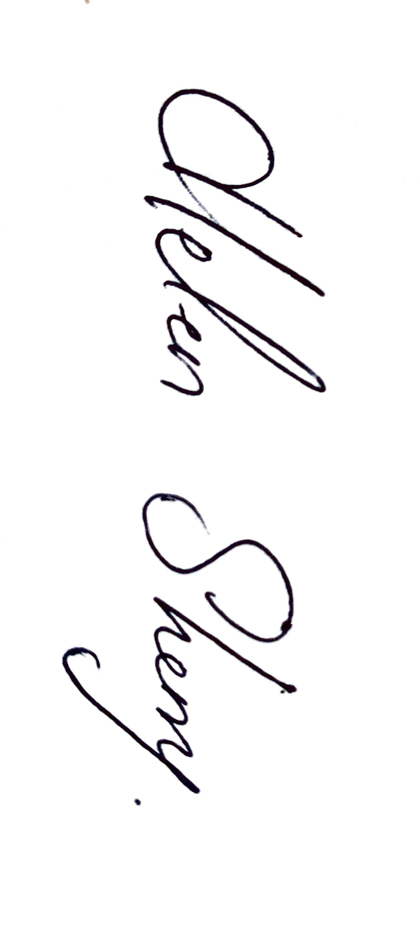
This policy was ratified by the Board of Management of Cuan na Gaillimhe CNS on the 24 October 2016 and the Parent Teacher Association was consulted in drawing up the policy. The Policy was revised on 24th of September 2018, 25th of March 2019 and on the 11th September 2024.
Signed: 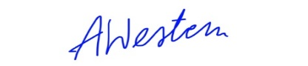 Signed:
Chairperson of Board of Management Principal/Secretary to the Board of Management

Date: 11th September 2024 Date: 11th September 2024

To be reviewed: January 2026
Cuan na Gaillimhe CNS
- a Steiner educatiOn

An Cimín Mór, Cappagh Road Knocknacarra, Galway, H91Y38E Roll No: 20462d Tel: (091) 867 387
www.cuannagaillimhecns.ie

I have read the school’s Code of Behaviour with my child and will support Cuan na Gaillimhe CNS in implementing it in relation to my child while s/he is a pupil of the school.

Name of pupil (please print)

Signed Date Parent/Guardian

My parents have read the Code of Behaviour with me and I agree to follow the School Rules

Signed (from 1st class up only)

Name of pupil (please print)

Signed Date Pupil

