

Cuan na Gaillimhe CNS
Reconstitution of Classes Policy

Introduction
Cuan na Gaillimhe CNS Class Formation and Reconstitution Policy was drawn up following consultation with the Teaching Staff and the Board of Management of the school.
The Board of Management and staff of Holy Well NS believe that reconstituting classes benefits all children from a social, developmental, behavioural and academic point of view. All children should be afforded the opportunity to make new friends throughout their primary school life, all in the secure and nurturing environment of our school.
Reconstitution of classes
The Principal and Board of Management, in consultation with the Staff may decide to reconstitute classes if deemed to be in the best interests of the pupils. In such a circumstance the decision will be made towards the end of the second term and relayed to parents in term three.
Please also note that the reconstitution of other classes may be necessary at times, dependent on DES teacher allocation. In accordance with the Department of Education and Skills, the organisation of pupils and classes is deemed to be the remit of the Principal. Circular16/1973: The Principal Teacher and Organisation 12. In consultation with the staff, the Principal should decide on the organisation of the pupils for teaching purposes.
Rationale In keeping with the Cuan na Gaillimhe CNS Mission Statement, the school is committed not only to the intellectual, moral, physical and spiritual development of each child but also to their emotional and social development. It is in this context that we promote the importance of positive relationships and endeavour to equip the pupils with the skills to form and sustain friendships with their peers.
Principals and teachers endeavour to create a positive learning environment that balances the needs and abilities of all the children within each class level. It is possible that in a large school children can go on to secondary school without ever having the opportunity of getting to know many of the children from their own year.
The system of reconstitution has gained wide acceptance from Board of Management’s, children, parents and teachers and is becoming more common practice in schools. The process is time consuming and depends largely for its successes on the teachers who designed it but it is widely accepted to be very worthwhile on many fronts.
The majority of our pupils are very happy in school, and they always have a friend to play with and rarely feel left out or alone but this is not always the case. We have found that as pupils move up through the school different groups can develop and at times a sense of isolation can deepen, and some pupils are never afforded the opportunity to explore new friendships. This sense of stagnation can affect the happiness of our pupils which in turn can impact on their learning. If a child is being left out or isolated by a group for a reason that is not apparent to them, this is far more upsetting to the pupil than when the opportunity to make new friends is presented to them, as it will be when the classes are reconstituted.
“It is easier for children to be pragmatic, and to move on, when they don’t feel any sense of rejection by their friend choosing not to be a friend. Even the loss of a friend, like when a friend’s family moves away, is easier to bear when the reason for the separation is more transparent, and due to the decisions or actions of others. Your child may still feel the loss of their friend … but they are often quicker to recover, including branching out to make new friends when they know that their friend didn't make an active choice to leave them”. David Coleman, Clinical Psychologist, 2016.
Reconstitution will help to further develop their social skills and to continue to expand their friendship groups.
The classes will continue to have lots of interaction together in yard, school tours, during sports events and as they work collaboratively on many aspects of school life.
Aims
The principle aims of reconstituting classes are:
❖ to maximise the learning outcomes for each child
❖ to develop the children's social skills and to better equip them to form friendships
❖ to ensure that each child has the opportunity to mix with a larger number of their peers.
❖ to facilitate mixed-ability groups
❖ to minimise tensions where difficult relationships exist Criteria In the formation or realignment of classes the following criteria may be considered:
❖ Mixed ability
❖ Teacher knowledge of pupils
❖ Teachers’ professional opinion
❖ Gender balance
❖ Individual needs of children
❖ Classroom dynamics and relationships
❖ Age
❖ Maturity including social, emotional, physical and interpersonal skills
❖ Family considerations e.g. twins, siblings, cousins, other family relationships
❖ Teacher Allocation (as per Department of Education)
❖ Pre-school information and friendships (incoming Junior Infants only)
Other considerations:
❖ It is considered best practice to form mixed ability groups.
❖ The dynamics of the class must be considered. Emotional, behavioural and social factors could upset the dynamic of the new class and will be taken into consideration when forming new groupings.
❖ All classes should be balanced in terms of special educational needs of pupils.
❖ The needs of pupils with SNA access will be central to any allocation.
❖ Previous composition of classes (if applicable) will be examined when forming new groupings. Benefits of reconstituting classes:
❖ Pupils may achieve better academic outcomes, as classes are balanced in terms of gender, academic ability, special educational needs, language development, social skills and behaviour
❖ Children are given the opportunity, over the years, to meet and get to know a wide range of children of similar age. This is very important for their social development and this links into the SPHE programme
❖ It contributes to the development of each child's sense of self and self-identity.
❖ It is good preparation for secondary school, as it helps children to be familiar with change within a safe environment, and with the support of friends.
❖ When they move on to secondary school, they are more likely to be in the same class as children they know well and from whom they can get support. It will also facilitate friendships-formation.
Method for reconstituting classes Early in the second term the SPHE programme has a focus on friendship and teachers teach a series of lessons on the importance of friends and what friendship means.
At the end of this process, each child will fill in a personal reflection sheet about school and their friends (The Senior Infants will be assisted by the class teacher in writing the names)
At the start of the third term a meeting will take place between all staff members associated with the classes to be reconstituted. Mainstream teachers, SEN teachers and the Principal will work together to devise the new class groupings and will endeavour to place the pupils with at least one friend.
Professional experience and best judgement will be used. Class lists are finalised at the end of this process. It will seldom be possible to satisfy all demands for groups of friends to be kept together.
The decision will ultimately lie with the Principal, who must consider the needs of every pupil in the school. During the last term the class teacher will conduct a survey with the pupils to gather information on what the pupils are looking forward to and their concerns prior to the reconstitution of classes.
Lessons will be devised following this, focusing on the concerns the pupils have, with the aim of alleviating any worries pupils have. Before the school year ends, the pupils will come together with their new class group and spend time in their new classrooms with their new teacher (if appointed). The teacher will do some bonding activities with the class. The process is carried out with great care and professionalism, with the interest of every pupil carefully considered.
Role of Parents
The process of forming new friendships is a life skill which is important to develop. Your positive and supportive attitude is a key element in achieving a successful outcome of the new class group. Your first concern will be for your child’s happiness.
Please see Appendix A for guidelines Conclusion Children and teachers know their new class by the end of the school year, before they go on holidays. This policy was formulated to ensure that the formation and reconstitution of classes is carried out in the best interests of all pupils.
Parents know that this process is carried out with great care and professionalism, and that each and every child's interests are carefully considered. Children adapt very easily and become very open and flexible in their social interactions with their new classmates. We have seen positive results from previous reconstitution of classes. Once class lists have been finalised, the class is non-negotiable and there will be no re arranging to suit individual parents, as this is school policy.

Ratification and review
This policy was amended and formally ratified by the Board of Management on 11/09/2024. This policy will be reviewed and amended, if necessary, in the second term of the 2024/2025 school year. It will be uploaded to our website and in the Enrolment Registration form so that every parent is fully aware of the reconstitution system in place in the school when they enrol their child.

Appendix A:
Frequently asked questions
What if my child is separated from his/her friends?
Please bear in mind that there are four classes to be reconstituted. Your child will be with some of their classmates from their original class. We will endeavour to place your child with at least one friend from their friendship group.
But my child is no longer with his/her best friend?
Perhaps not, but while your child is engaged in learning in the class they will be mixing with new friends and can play with whoever they choose in yard and after school. Parents can continue to organise play dates with original friends and some new friends too.
Will the school be grouping the classes according to ability?
No, we will not. All classes will remain mixed ability.
How will I know who my child’s new classmates and their parents will be?
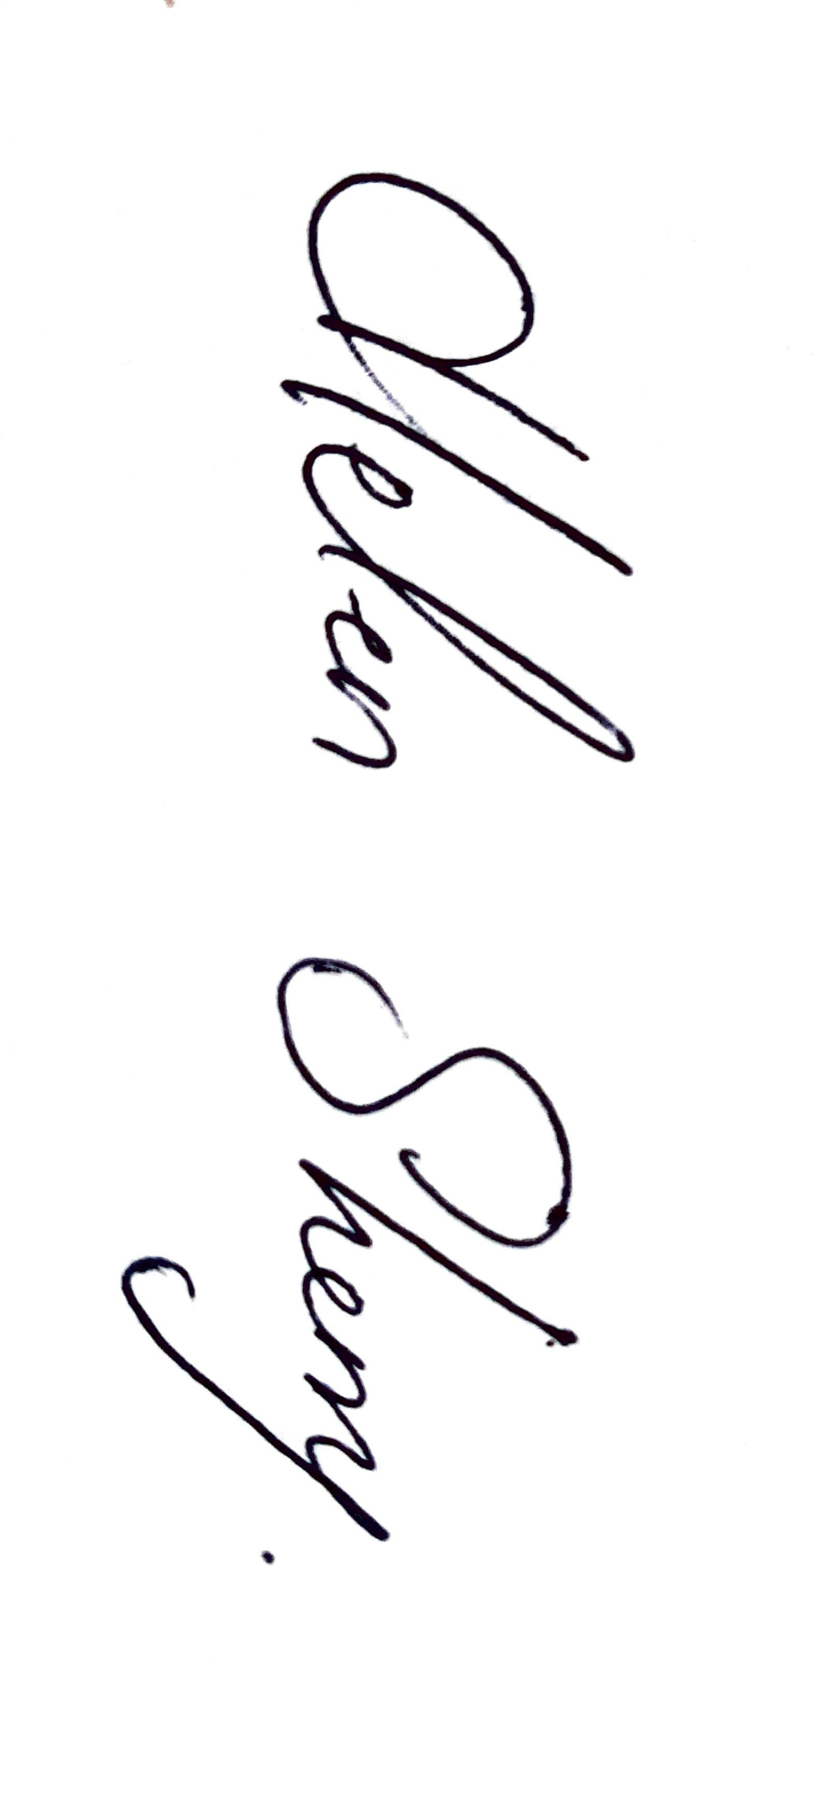
In June each parent will receive an email with details of the Class Teacher and classroom for the coming September. Unfortunately, due to GDPR we are unable to send full class list to parents.

Signed: 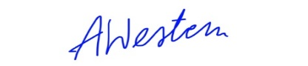 Date: 11th September 2024
Signed: Date: 11th September 2024

